LASSO regression used to select important features when predicting wheat yield from various germplasm groups

Muhuddin Rajin Anwar^{a,b,*}, Livinus Emebiriª, Ryan H. L. Ip^{c,d}, David J. Luckett^{b}, Yashvir S. Chauhan^{e}, Ketema T. Zeleke^{b,f}

ªNSW Department of Primary Industries, Wagga Wagga Agricultural Institute, Wagga Wagga, NSW 2650, Australia.
^{b}Gulbali Institute (Agriculture, Water and Environment), Charles Sturt University, Locked Bag 588, Wagga Wagga, NSW 2678, Australia.
^{c}School of Computing and Mathematics, Charles Sturt University, Wagga Wagga, NSW 2650, Australia.
^{d}Department of Mathematical Sciences, Auckland University of Technology, Auckland, New Zealand
^{e}Department of Agriculture and Fisheries (DAF), Kingaroy, Queensland 4610, Australia.
^{f}School of Agricultural, Environmental and Veterinary Sciences, Charles Sturt University, Wagga Wagga, NSW 2650, Australia.

*Corresponding author. E-mail: muhuddin.anwar@dpi.nsw.gov.au (M.R. Anwar)

Highlights
• LASSO regression modelling allowed identification of the most influential stress variables affecting the grain yield of bread and Durum wheat grown in field experiments across two sites, multiple years, and two sowing times.
• The influence of crop water supply-demand ratio was an excellent index to summarise water relations and drought stress. Its expression depended upon the growth period examined and the germplasm grouping.
• Evapotranspiration was important only in the vegetative phase (pre-flowering) while drought and heat stress were most important around flowering time.
• Graphs of predicted versus actual yield may help identify wheat genotypes that have a greater-than-expected stress tolerance or avoidance.

Abstract
Bread wheat and Durum wheat genotypes were grown in field experiments at two locations in New South Wales, Australia across several years and using two sowing times ('early' versus 'late'). Genotypes were grouped based on genetic similarity. Grain yield, grain size, soil characteristics, and daily weather data were collected. The Weather data was used to calculate water and heat stress indices for four key growth periods around flowering. LASSO (least absolute shrinkage and selection operator) was used to predict grain yield and to identify the most influential features (a combination of index and growth period). A novel approach involving the crop water supply-demand ratio (SDR) effectively summarized water relations during growth. LASSO predicted grain yield quite well (adjusted R2 from 0.57 to 0.98), especially in a set of Durum genotypes. However, the addition of other important variables such as lodging score, disease incidence, weed incidence, and insect damage could improve modelling. Growth period 2 (30 days pre-flowering up to flowering) was the most sensitive for yield loss from heat stress and water stress for most features. Although one group of bread wheat genotypes was more sensitive to water stress (drought) in period 3 (20 days pre-flowering to 10 days post-flowering). Evapotranspiration was a significant positive feature but only in the vegetative phase (pre-flowering, period 1). This study confirms the usefulness of statistical modelling as a technique to make predictions that could be used to identify genotypes that are worthy of further investigation by breeders for their stress-tolerance ability.

Keywords: Triticum aestivum, LASSO-regression, yield, germplasm, SDR, water-use efficiency, heat stress, water stress

1. Introduction
Wheat (Triticum aestivum L.) is the world's third most abundant staple cereal food crop, behind maize and rice in terms of production. The OECD/FAO (2023) reports that its annual output for the 2022-2023 period was approximately 800 million tons. In Australia, it is the fifth most exported commodity (OEC, 2023). However, climate change-induced abiotic stresses, such as drought and elevated temperatures, pose significant challenges to wheat production (Collins and Chenu, 2021). These stresses are expanding and intensifying, and impacting global wheat yields (Lobell et al., 2011). Additionally, water scarcity significantly hinders wheat cultivation in Australia, prompting growers, breeders, and agronomists to focus on improving water usage efficiency (Sadras and McDonald, 2012). Durum wheat (Triticum turgidum L. subsp. durum (Desf.) Husn.) is a secondary wheat crop in Australia – grown for use in pasta production (GRDC GrowNote, 2017). Its annual production in Australia hovers around 0.5 million tonnes – much less than the total for bread wheat of about 36 million tonnes in 2022 (ABS 2024).

High temperatures during critical crop development stages, such as flowering, can reduce grain yield by directly affecting grain number and grain weight (Trethowan, 2022). This has been shown in several studies, including Stone and Nicolas (1994), Talukder et al. (2014), and Wollenweber et al. (2003). Even a short period of high temperature during flowering can significantly reduce grain weight and set, especially in sensitive cultivars (Talukder et al., 2013). For example, a field experiment by Nuttall et al. (2012) showed that a temperature of 36–38 °C for 6 days after flowering resulted in a 12% reduction in grain number and a 13% loss in grain yield.

Climate change poses a significant threat to global wheat production. Environmental factors like water shortages and high temperatures significantly impact global wheat production through plant phenotypic and physiological changes (Abhinandan et al., 2018). Studies indicate that for each additional degree of global mean temperature increase, wheat yields could decline by up to 6%, under the assumption of no CO₂ fertilization, continued effective management practices, and no changes in crop genetics (Asseng et al., 2015; Zhao et al., 2017). This impact is already evident in Australia, where simulations suggest a huge and concerning 27% decline in water-limited potential wheat yield from 1990 to 2015 (Hochman et al., 2017). This decrease is likely attributable to a combination of stressors such as seasonal rainfall and increased temperatures, coupled with the limited ability of increased atmospheric concentration (CO₂) to fully compensate for these negative factors (Wang et al., 2017; Li et al., 2022). While climate change and climate variability present major hurdles, analysing the connections between climate, soil, and wheat yield empowers us to design actionable strategies to mitigate yield losses. By unravelling the relative importance of various variables, we can guide future research towards developing climate-resilient wheat cultivars and innovative management practices, ultimately transforming vulnerability into opportunity.

In any individual wheat crop, in addition to gross climatic and edaphic influences, many other biotic and abiotic stresses will affect crop growth and yield. In this work, we were particularly interested in abiotic soil water deficit and heat stresses, especially during the reproductive period of the crop’s growth. We wanted to explore how we can use soil characteristics and weather variables to improve the prediction of phenology and yield via modelling. In addition, we wanted to identify the most influential variables and the most sensitive crop growth period upon which these variables act. The least absolute shrinkage and selection method (LASSO) has shown good utility for identifying the most influential variable in a multiple-regression situation of this type (Tibshirani, 1996; Didari et al., 2023). This methodology may assist wheat breeders by identifying different influential variables depending on the type of wheat germplasm being examined. In addition, if other traits are of interest, the same approach can be used to dissect the influential variables (Shafiee et al. 2021).

The specific objectives of this study were as follows.
Firstly, to utilise an existing wheat dataset comprising six sets of bread wheat and durum wheat germplasm (each consisting of a variable numbers of genotypes), grown in experiments at two sites and up to two sowing times over several years, for research into the possibility of predicting grain yield from a suite of weather- and soil-based climatic variables: particularly, crop water-use, crop water stress, and crop heat stress.

Secondly, to determine which of those variables were most influential and effective for predicting yield using the relatively new regression technique of LASSO, and to see whether the germplasm groups showed different responses.

Thirdly, to calculate the weather and soil-based variables across four different crop growth periods (overlapping development stages), and to see which weather and soil-based variables were most influential in predicting yield.

Fourthly, using the combined findings, to identify the most critical growth period for crop damage (yield loss) from water stress and/or heat stress in the different germplasm groups, with the aim of informing wheat breeders which crop traits merit attention for reducing losses of potential yield from water- and heat-stress.

2. Materials and methods

2.1 Study area and soil data
Two typical rainfed crop-livestock growing locations (Leeton and Wagga Wagga) in southeast Australia, encompassing different climatic conditions, were selected for analysis (Table 1) utilising an existing dataset previously published for other purposes (Sissons et al., 2018; Zeleke et al., 2023). The soils across the sites are predominantly Wunnamurra Clay (Leeton) and kandosol (Wagga Wagga) according to the Australian Soil Classification (Isbell and National Committee on Soil and Terrain, 2021). The soil properties at these sites have been summarized by others (Xing et al., 2017; Wang et al., 2017). Briefly, at Leeton, the plant available water holding capacity (PAWC) was 293mm, to a total soil depth of 1.8m, pH (1:5 water) ranged from 7.2 – 8.9, bulk density (g/cc) of 1.20 to 1.40 and initial nitrate (NO₃) was 81 kg/ha. At Wagga Wagga, the PAWC was 128mm, to a total soil depth of 1.25m, pH (1:5 water) ranged from 6.2 – 6.9, bulk density was 1.37 to 1.56 g/cc, and initial NO₃ was 69 kg/ha. These sites have been the subject of parameter verification in wheat cropping systems (Anwar et al., 2015; Anwar et al., 2022) especially for the numerous initial values and parameters required for running the APSIM crop growth model (https://www.apsim.info/).

2.2 Field experiments and agronomy
The layout of the field experiments, the details of the genotypes used, and the agronomy used during each year are detailed in a previous publication (Sissons et al., 2018; Zeleke et al., 2023). Briefly, the experiments were conducted at Leeton in 2011 and 2015 and at Wagga Wagga in 2012, 2018 and 2019. Two sowing times were used at each site/year: ‘early’ and ‘late’, in order the maximise the differences in the weather experienced by the crops. Not all germplasm sets were grown in every site/year. Here we note, in addition, that some lodging occurred in the field along with some fungal disease; the genotypes were variously affected but the scoring used was unfortunately inconsistent. Consequently, in this analysis these factors were not included in the LASSO modelling (see below) and may have contributed to some imprecision in the predicted values.

2.3. Wheat Germplasm groups
ABD lines: These are advanced breading lines of wheat (Triticum aestivum) produced at the International Maize and Wheat Improvement Centre (CIMMYT), Mexico. They are comprised of the line selections from the high-temperature wheat yield trials (HTWYT), and selections made for their large grain size (Sissons et al. submitted). Hereafter referred to as “BreadWheat_ABDLines”.
Elite wheat: These are bread wheat varieties of historical significance, recently released cultivars, and parents used in breeding programs by the major private breeding companies (InterGrain, LongReach, and Australian Grain Technologies) in Australia. These varieties have been bred to meet the specific needs of Australian growers, such as resistance to diseases and pests, tolerance to heat and drought, good grain quality, and high yield, and were chosen based on being potentially heat tolerant (or in some cases intolerant) according to Australian breeder recommendations and the literature (Sissons et al., submitted). Hereafter referred to as “BreadWheat_Elite”.
Landrace wheat: The bread wheat landraces were sourced from heat-prone areas in Afghanistan, Iran, Iraq, and India. They were identified using FIGS (focused identification of germplasm strategy), an approach that uses environmental parameters described in plant germplasm collection sites as selection criteria to identify materials that most likely have undergone selection pressures for the target parameters (Sissons et al., 2018). Hereafter referred to as “BreadWheat_Landraces”.
Tamaroi x Saintly durum bi-parent population: These are durum wheat doubled-haploids, which were produced from F₁ plants of a cross between the SA-bred variety, Saintly and the NSW-bred variety, Tamaroi. Saintly has a reputation for performing well in seasons with terminal drought stress, while the variety Tamaroi has a very high inherent 1000-kernel weight but is susceptible to heat stress. Hereafter referred to as “Durum_Biparent”.
Durum elite: The durum wheat germplasm comprised a worldwide collection trialled for heat tolerance in southern Australia (Collins et al., 2017). They included commercial durum varieties and breeding lines, along with tetraploid wheat landraces sourced from heat-prone regions by using the FIG strategy (Street et al., 2016). They have been shown to exhibit significant variability for tolerance/intolerance to late-sown heat stress (Sissons et al., 2018) and natural heat waves (Emebiri et al., 2024). Hereafter referred to as “Durum_Elite”.
Bread wheat NI lines: The near-isogenic (NI) lines were created from a cross of wheat varieties Drysdale and Waagan. Both parents are semi-dwarf varieties and carry genetic loci for intolerance and tolerance, respectively, to both booting and grain filling stage heat stress (Shirdelmoghanloo et al., 2016; Erena et al., 2021). The NI lines were created by using molecular markers to identify single Drysdale × Waagan F_{2:8} plants that were heterozygous for genetic loci located on wheat chromosomes 2B, 3B and 6B; then the progeny of these plants was screened to identify plants homozygous for each allele at the respective loci (Erena et al., 2021). Hereafter referred to as “BreadWheat_NILines”.

2.4. Soil water balance
Rainfall, evapotranspiration (ET), runoff, and drainage are key factors that affect how much water is available to crops (Unkovich et al., 2018; Unkovich et al., 2023). In this study, temperature, rainfall, simulated initial soil water content, and simulated soil water content at harvest, were used to calculate the soil water balance following the procedure of He and Wang (2019). We used the pre-validated Agricultural Production Systems sIMulator (APSIM) that simulates the key biophysical processes related to crop growth and production, water, carbon, and N cycling in the soil-plant system (Holzworth et al., 2014). Published studies have also used the APSIM model to calculate hydraulic parameters for wheat cropping systems (such as, soil water content at sowing and harvest, water use, runoff, drainage, and soil evaporation). The parameters in the Soil Water module of APSIM were the same for our sites as those used in other published work (Liu et al., 2014; Zeleke and Nendel, 2019; Wang et al., 2017; Xing et al., 2017). To estimate the initial soil water content at the start of the experimental period (2011), we assumed that the starting soil water on 1 January 2002 was equal to LL15 (water content at 15 bar suction). Then by running APSIM for the 2002-2011 period using actual weather data we simulated the initial soil water in 2011 (He and Wang, 2019). The LL15 value was determined in the Wagga Wagga Agricultural Institute soil moisture analysis laboratory (Anwar et al., 2022). The APSIM model was then run continuously until the end of the experimental period (31 December 2019), without resetting soil water conditions, to obtain the “initial soil water at sowing” and the “soil water at harvest” for each of the wheat experiments (Sissons et al., 2018). The APSIM crop sequence used in the 10-year run-up period before the wheat experiments commenced was a typical one used in the wheat growing regions in Australia: wheat(W)-canola(C)-chickpea (CP)-W-C-CP-W-C-CP-W.

Total crop water use (WU) expressed as evapotranspiration (ET) was calculated by subtracting the final soil water content at harvest from the initial soil water content at sowing and adding the amount of irrigation and rainfall received during the growing season (1).

ET = P + SWs – SWh – R – D (1)

where P, R and D are cumulative rainfall, runoff, and deep drainage from the day of sowing to harvest, and SWs and SWh are soil water at the sowing and harvest dates, respectively (Yang et al., 2016).

In contrast, Transpiration (T), which does not include soil evaporation (E) (eqn 1), was calculated using the following soil water balance equation (2) (Yang et al., 2016).

T = P + SWs – SWh – R – D – E (2)

The APSIM soil water module also calculates daily potential evapotranspiration using the Priestley-Taylor method (APSIM, 2023), which is based on the physiological relationship between crop yield and evapotranspiration (Paredes et al., 2014; Trout and DeJonge, 2017; Akumaga and Alderman, 2019).

2.5. Water supply-demand ratio (SDR)
The APSIM model calculates a water-deficit index (Chapman et al., 1993; Chenu et al., 2011), also known as the "water supply” and “water demand " ratio, which indicates how well the water extractable by the crop’s roots (water supply) meets the crop’s potential transpiration (water demand). The crop water supply is calculated for each layer of the soil where roots are present and depends on the root growth and soil property of each layer. The water demand is the amount of water the crop would have transpired in the absence of soil water constraint. It is estimated daily based on the amount of crop growth on that day and the atmospheric saturation vapor pressure deficit.

Water supply-demand ratio (SDR) is the ratio between water supply and water demand, bounded between 0 and 1, which indicates if the plant is water-stressed.

$SDR=\left\{\begin{aligned}\min\left(\frac{Supply}{Demand},1\right), &Demand>0 \\ 1, Demand=0\end{aligned}\right.$ (3)
When SDR = 1, there is no water stress. Otherwise, the plant is stressed. Based on SDR, we define water deficiency (D) such that:
D=1-SDR (4)
The interpretation is the opposite of SDR. When D = 0, there is no water stress. Positive D indicates stress. Daily deficiency values were calculated and were accumulated within the following four crop development periods, each spanning approximately 30 days (see below).

2.6. Wheat developmental period
Abiotic stress during the reproductive stage of plants (anthesis and grain filling) has a significant effect on grain yield and quality. The critical period for abiotic stress is the time when plants are most sensitive to these stresses. Some previous studies have defined the critical period as 30 or 45 days before to 0 days after 50% anthesis (Fischer, 1985). Other studies have found that the critical period is narrower, spanning only about 20 days before to 10 days after anthesis (Ortiz-Monasterio et al., 1994; Abbate et al., 1995). More recently, Slafer et al. (2023) found that the critical period for wheat is from 30 days before to 10 days after anthesis.
In this study, we defined and examined four contrasting crop growth periods based on previously published studies:

Period 1: From sowing to the day of flowering (varying lengths)
Period 2: From 30 days before flowering to the day of flowering (30 days total)
Period 3: From 20 days before flowering to 10 days after flowering (30 days total)
Period 4: From 15 days before flowering to 15 days after flowering (30 days total)

We chose these 30-day intervals based on the findings of previous studies (Fischer, 1985; Slafer et al., 2023). There is considerable chronological overlap between these periods, but we wanted to test which of these periods might be most sensitive to stress effects on grain yield. By definition, Period 2 overlaps with Period 3 by 67%; Period 2 overlaps with Period 4 by 50%; and Period 4 overlaps with Period 3 by 83%. The degree to which Period 1 overlaps with the others depends on the interval from sowing to flowering (in days). The means and ranges for the sowing-to-flowering interval for each germplasm group across each Site/Year/Sowing-time combination are given in Table S2 in the Supplementary Material. The overall mean of this duration was 106.0 days. The mean overlap (and the ranges) between Period 1 and Period 2 was 28.8% (21.5% - 38.8%). For periods 1 and 3 the corresponding data were 19.2% (14.3% – 25.9%). For periods 1 and 4 they were 14.4% (10.8% – 19.4%).

2.7. Statistical techniques and least absolute shrinkage and selection operator (LASSO)
Firstly, we examined some basic summary statistics for each germplasm set and each sowing time (across both sites and all years). Since the “early” (coded as “1”) and “late” (coded as “2”) sowing times were designed to present the crops with contrasting stress environments, we were expecting to see quite large differences in means and ranges for the traits of interest.

Secondly, to investigate the impact of daily abiotic stress indices (heat stress, water deficit and evapotranspiration) on wheat yield, accumulated over four key growth stages, we used the following approach.

Pearson correlation coefficients were calculated to assess the relationship between yield, 1000 grain weight (TGW), evapotranspiration (ET), transpiration (Tran), accumulated water deficit (water supply-demand ratio), and heat stress (number of days with temperatures >30ºC). Correlation analysis was restricted to Period 3 only (20 days before flowering to 10 days after flowering, see above) because this flowering period has proven to be the most important with respect to yield in other published papers (see above). All data were normalized to zero mean and unit variance prior to analysis.
Thirdly, to study the relationship between wheat yield (the target trait) and daily stress indices (the explanatory variables) accumulated over critical periods of growth (the four “periods”) and across different sets of genotypes (the germplasm groups) we undertook LASSO regression analysis. In linear models such as multiple linear regression models, it is often assumed that the explanatory variables are independent (Monahan, 2011). When explanatory variables are correlated, multicollinearity is said to exist (Kutner et al. 2005). As a result of multicollinearity, the estimation of coefficients can become unstable, leading to unreliable estimates. In some extreme cases, the regression coefficients do not reflect the inherent relationship between the explanatory variable and the response variable. For example, a negative coefficient may be obtained although the relationship should be positive.
For better interpretability, many statistical methods have been proposed to deal with multicollinearity, many of which are aimed at minimising the prediction error while forcing (i.e., “shrinking”) some of the regression coefficients to zero, hence effectively removing some of the explanatory variables and highlighting the most influential ones (Dormann et al, 2013). Among these methods, LASSO (least absolute shrinkage and selection operator; Tibshirani, 1996) is a popular choice. In this work, we adopted LASSO to find the best subset of explanatory variables from the large initial number. To obtain scientifically sensible regression coefficients, constrains were imposed on them in the estimation procedure. Specifically, the coefficients of variables related to heat and water stresses were set to be non-positive. The computations were performed using the “glmnet” package in R (Friedman et al., 2010).
For data preparation, summarisation, and graphics extensive use was made of the “tidyverse” R packages (Wickham et al., 2019), the RStudio GUI (RStudio Team 2023), and the R software suite (R Core Team, 2023).

3. Results
3.1. Data summaries across sites, genotype groups and sowing time
The Wagga Wagga soil, compared to Leeton, is a shallower and more dense soil, with lower pH, which holds much less water than Leeton (Table 1). Both sites face sizeable year-to-year variations in the climate variables (rain, solar, and temperatures). Wagga Wagga gets more rain, both overall and during the growing season, with Wagga Wagga's temperatures being slightly cooler than Leeton.
We note that the number of genotypes is not the same between the two sowing times within a germplasm group (category), although there was considerable overlap. The frequencies of concurrence of genotypes across “site_year_sowing-time” are given in Table S1. This was due to practical issues, such as the lack of seed supply. The “BreadWheat_NILines” group was only sown once, while the “Durum_Elite” category had only a small number of genotypes. Both of these groups were excluded from the LASSO analysis.
While there was a large variation within each germplasm category, the grain yield (Table 2) was always substantially lower in sowing-time_2 due to higher stress levels with an overall range of nearly 9 tonnes per hectare to less than 0.2 tonnes per hectare. Grain size was similarly reduced in sowing-time_2 except for the “Durum_Biparent” category (Table 2).
The mean total transpiration (Tran) and mean total evapotranspiration (ET) were always higher in sowing-time_2 (Table 3) due to the crops growing in a hotter and drier period of the year, with ET always greater than Tran (as expected). Water use efficiency (both WUE_TRAN and WUE_ET) were much reduced in sowing-time_2 compared to sowing-time_1, often by more than 50%. The WUE_Tran ranged overall for individual genotypes from 57.5 to 0.92 kilograms of grain per hectare per millimetre, whereas WUE_ETA ranged from 33.5 to 0.6 kilograms of grain per hectare per millimetre (Table 3).

3.2. Correlation analysis
Tables 4 to 9 shows the correlation coefficients between yield, 1000 grain weight (TGW), evapotranspiration (ET), transpiration (Tran), accumulated water deficit (SDR = supply-demand ratio), and heat stress (H>30 = number of days with temperatures >30 ºC). Generally, the correlations between traits were highly significant (either positively or negatively) within each germplasm category but significance levels were much lower (or non-existent) in the “BreadWheat_Landraces” and the two Durum categories. The Tran and ET variables were always highly positively correlated (as expected). The H>30 (index of heat stress) was usually highly positively correlated with both Tran and ET but was not significant in the “BreadWheat_Landraces” category (Table 6) nor for ET in the “Durum_Elite” category (although the number of values was small, n = 10, Table 9).
The TGW and grain yield were generally positively correlated but again not within the “BreadWheat_Landraces” group (Table 6), and were strongly negative in the “Durum_Biparent” material (Table 8). The SDR (index of water stress) was usually negatively correlated (when significant) with the other traits but a contrasting positive correlation was seen in “BreadWheat_ABDLines” material with TGW (Table 4), and with Tran and ET in “Durum_Biparent” material (Table 8).
Tran and ET were generally significantly negatively correlated with both yield and TGW, except in the “BreadWheat_Landraces” group (Table 6) and in “Durum_Biparent” (Table 8). As expected, the numerous genotypes in the “BreadWheat_Landraces” category provided the greatest range in performance (yield and TGW), water use (Tran and ET), and water use efficiency (WUE_Tran and WUE_ET), plus less rigid inter-trait correlations.

3.3. Distributional characteristics of water and heat stress and evapotranspiration
Environmental factors like water shortages and high temperatures significantly impact global wheat production through plant phenotypic and physiological changes (Abhinandan et al., 2018). For each of the four growing periods in this study, the intensity and frequency of water stress (calculated via supply-demand ratio; SDR) and heat stress including evapotranspiration are summarised below for individual genotypes within six germplasm groups.

In Figure 1, each boxplot shows the distribution of accumulated values of SDR for a single germplasm group and growing period combination. There is a considerable amount of variability in SDR within each germplasm group and growing period. The boxes, which represent the interquartile range (IQR), span a wide range of values in most cases. The whiskers, which extend to the most extreme data points not considered outliers, also show a wide range of values for many of the groups and periods. The medians (represented by the horizontal lines within the boxes) are generally lower for groups and periods with higher SDR. For example, in the first growing period, the median SDR for the BreadWheat_Elite group is around 10, while the median SDR for the same group at third growing period decreased to about 4.8. The dispersion, or spread, of the data is also influenced by SDR. The boxes tend to be wider for groups and periods with higher SDR, indicating that there is a greater range of SDR values within those groups. For example, in the second growing period, the box for the BreadWheat_Elite group is wider than the third growing period. In contrast, BreadWheat_NILines group didn’t show dispersion but higher SDR values in the first and fourth growing periods compared to the second and third growing periods. From Figure 1, it can be seen that the SDR decreases from growing period 1 to growing period 4 for all the genotypes. For three of the genotypes (BreadWheat_ABDLines, BreadWheatNILines, Durum_Wheat), the lowest SDR is in growing period 2.

The potential evapotranspiration (Fig. 2) exhibits considerable variability within each germplasm group and growing period, as evidenced by the interquartile ranges and whiskers of the boxes. The degree of dispersion in evapotranspiration values differs across germplasm groups and growing periods. For instance, Durum_Elite lines generally demonstrate a more compact distribution of evapotranspiration values compared to BreadWheat_ABDLines, suggesting greater consistency in water use within the Durum_Elite group. The median evapotranspiration values vary across germplasm groups and growing periods. Notable trends include BreadWheat_ABDLines tend to have higher median evapotranspiration values than other groups across most growing periods. Durum Elite lines generally exhibit lower median evapotranspiration values, particularly in growing periods 2 and 3. BreadWheat_Landraces display a wider range of median evapotranspiration values across growing periods. Th Potential evapotranspiration of growing period 1 > 4 > 3 > 2. Growing period 1 has the highest potential evapotranspiration and growing period 2 has the lowest potential evapotranspiration. Compared to the other genotypes, BreadWheat_Landraces has the highest potential evapotranspiration for each of the respective growing periods and high variability in evapotranspiration across growing periods, suggesting that water use strategies of genotypes may vary depending on environmental conditions and crop developmental stages.

Figure 3 shows a wide range of variability in heat stress within each germplasm group and growing period. The boxes show the middle 50% of the data, with the whiskers extending to the 10th and 90th percentiles. For example, in the BreadWheat_ABDLines group, the heat stress ranges from 0 to 15 days across the growing period. The median heat stress is also different for each germplasm group and growing period. For example, the median heat stress for the BreadWheat_ABDLines group is about 7 days in the third growing period, while the median heat stress for the Durum_Biparent group is higher (about 15 days) in the same growing period. Figure 3 show that heat stress growing period 1 < 2 < 3 < 4. Growing period 1 has the lowest heat stress and growing period 4 has the lowest potential evapotranspiration. Durum_Biparent had the highest stress for a given growing period compared to the other genotypes.

3.4. LASSO feature selection
Our wheat data consisted of six germplasm categories (Table S2); however, when fitting a LASSO model, specific criteria must be met. In our case, the “BreadWheat_NILines” category only had one sowing time at one location; hence there was no variation in the explanatory variables, and this category was excluded from the final modelling. Similarly, the “Durum_Elite” category had too few observations (2 genotypes only) to allow the fitting of the explanatory variables. The interpretation of coefficients from LASSO is almost the same as in multiple regression models. The only difference is that LASSO ‘forces’ some of the coefficients to zero. Table 10 shows the estimated coefficients from LASSO and overall model performance.

In all four major germplasm categories, the effect of ET on yield was effectively zero except in Period 1 (where it presumably influenced vegetative biomass, which led to more yield), and in Period 4 for “Durum_Biparent” genotypes. Notably, in Period 1, the effect of ET on yield was higher for “BreadWheat_ABDLine” and “BreadWheat_Elite” compared to the other two germplasm groups. Heat stress (H) was damaging in all periods for the first two bread wheat categories and the “Durum_Biparent” set, but less so for the “BreadWheat_Landraces” set in Period 3. Yet, heat stress in Period 2 was found to be highly damaging for the “BreadWheat_Landraces” group. The results were more mixed for the water stress index (D), particularly detrimental in “BreadWheat_ABDlines” and in Period 3.

For BreadWheat_ABDLines (Table 10), wheat grain yield was found to be most severely affected by water stress in period 3, followed by heat stress in period 1. For each unit increase in water stress in period 3, yield is expected to decrease by 0.789 t/ha, assuming all other factors remain unchanged. Water stress in period 4, and ET in periods 2 to 4, were found to be relatively less influential to the grain yield. In "BreadWheat_Landraces" germplasm category, heat stress during period 2 had the strongest negative impact on wheat grain yield, reducing it by 0.725 t/ha. In contrast, water stress and evapotranspiration in all periods had minimal to no effect on grain yield. Among the germplasm categories in period 2, BreadWheat_Elite experienced the greatest yield reduction due to water stress, with an expected decrease of 0.501 t/ha and heat stress followed closely (yield decline of about 0.449 t/ha). Notably, evapotranspiration had no impact on grain yield for BreadWheat_Elite in periods 2, 3, and 4. Durum_Biparent appears to be less sensitive to water stress and heat stress than BreadWheat_ABDLine. In Durum_Biparent, heat stress had the greatest impact in period 2, with an expected yield decrease of 0.361 t/ha. This was followed by water stress with a decrease of 0.241 t/ha. Evapotranspiration had a positive effect on grain yield in periods 1 and 4, with increases ranging from 0.224 to 0.278 t/ha. However, it had no impact on yield in periods 2 and 3.

3.5. Yield prediction
LASSAO modelling predicts yield reasonably well (Figure 4) with highly significant positive regression between observed and predicted values: the “Durum_Biparent” relationship being particularly strong. There are some outlying groups of genotypes, for example in the “BreadWheat_Elite” category but these were very low yielding genotypes. As shown in Table 4, the root mean squared errors ranged from 0.119 to 0.976 t/ha across the four genotypes and the adjusted R² ranged from 0.57 to 0.98. So, overall, the LASSO approach is working well at predicting crop outcomes, especially for “Durum_Biparent”, from weather-based and soil-based indices. Some other explanatory variables (not considered in this study) are required to improve further the goodness of fit, such as disease scores, lodging scores, weed measurements, and crop plant density.

4. Discussion
Climate change throws a complex web of challenges at crop production, weaving together water deficits, scorching heat, and fluctuating evaporative demands (Anwar et al., 2015; Kerr et al., 2022). These interwoven environmental stresses act like a multi-pronged attack, inflicting far more damage on plant growth and yield than individual stressors do in isolation (Pandey et al., 2017). This "synergistic effect" can significantly cripple crop production, exceeding initial projections, as evidenced by numerous studies (Mittler, 2006; Prasad et al., 2011).

This study investigated the combined effects of abiotic stresses: heat, water deficit (SDR), and evapotranspiration, on various wheat germplasm categories in Australia. The findings highlight the intricate and multifaceted nature of understanding how multiple stressors impact crop performance.

Delayed sowing results in longer crop emergence time, slower growth, less ground cover, lower biomass, higher non-productive (evaporation) component of water balance. Late sown crop is exposed to higher temperature and evapotranspiration (ET) during critical crop development stage. Early sown crop has a deeper rooting system to access subsoil water during the reproductive growth stage (Zeleke and Nendel, 2019). For all the growth periods considered in this study (periods 1 to 4), the correlation between explanatory variables (TGW [1000 grain weight], ET, Tran [transpiration], SDR, H>30 [number of days with temperatures >30 ºC]) and dependent variable (grain yield) is different for different germplasm groups (results only shown for Period 3). This can be due to the inherent difference of the genotypes or due to pooled data from two sites and two sowing times. Heat, evapotranspiration, and transpiration are negatively correlated with yield. One would expect that the more a crop transpires, the higher will be the yield. However, in our data higher rainfall (or higher ET or Tran) years were affected by lodging, resulting in lower yield.

Our research confirms that climate change presents significant challenges for wheat production. The different growing periods exhibited variations in water stress, evapotranspiration, and heat stress (H>30 days), demonstrating the potential for diverse climatic pressures throughout the growing season (Nuttall et al., 2018). These stresses were found to significantly impact grain yield and plant characteristics like thousand-grain weight.

Interestingly, this study emphasizes that the combined effect of these stressors isn't simply additive. Interactions between factors like heat and water deficit can be complex and vary depending on the specific germplasm category and growing period. For example, while heat stress generally reduced yield in most wheat germplasm categories tested here, its impact was less pronounced in the "BreadWheat_Landraces" group in period 3, while water stress in period 2 had the largest detrimental effect for this group. Conversely, the "Durum_Biparent" group seemed less sensitive to stress overall, even showing a positive response to increased evapotranspiration in some periods (Sinha et al., 2021; Ru et al., 2023).
These findings underline the need for nuanced approaches to managing wheat crops under increasing climate variability (FAO, 2016). Selecting stress-tolerant varieties and implementing targeted strategies based on specific environmental conditions and germplasm characteristics will be crucial for ensuring food security in a changing climate. Further research exploring additional stress factors and their interactions will also be vital for optimizing wheat production and resilience.

While the LASSO model effectively captured the main stress effects (Shafiee et al. 2021), it's important to acknowledge the limitations. The observed stress-yield relationships likely involve intricate interactions that the model might not fully capture. For instance, the contrasting response of "BreadWheat_Landraces" to heat stress across different periods suggests potential moderating factors or complex physiological mechanisms at play. Further research delving deeper into these interactions and incorporating additional stress factors like salinity or nutrient deficiency could provide a more comprehensive understanding of how multiple stresses collectively impact wheat performance (Teixeira et al., 2013; Ru et al., 2023).

Despite these known limitations, the LASSO model demonstrated promising results in predicting yield based on weather and soil-based indices, particularly for the "Durum_Biparent" group. This highlights it’s potential as a tool for:
1) Identifying stress-tolerant genotypes: by analysing the LASSO coefficients and stress responses across diverse germplasm, researchers can prioritize genotypes with inherent resistance or resilience to specific stress combinations. This can be achieved by identifying germplasm categories that exhibit consistently lower yield reductions under various stress combinations.
2) Targeted stress mitigation strategies: understanding which stress factors are most critical for specific genotypes and growth periods allows for tailored interventions. For example, if water stress is the primary limiting factor for a particular germplasm category during a specific growth period, implementing irrigation scheduling strategies can be crucial. Conversely, for germplasm categories sensitive to heat stress, exploring heat stress management techniques such as by earlier sowing or by growing earlier maturing varieties or breeding for heat tolerance can be prioritized.

To summarise, the LASSO analysis provided valuable insights into the diverse and complex ways that abiotic stresses impact wheat yield across different germplasm categories. While further research is needed to fully understand the intricate interactions between stresses, this study demonstrates the potential of LASSO as a tool for predicting and managing stress impacts, ultimately contributing to improved wheat production and food security in a changing climate.

5. Conclusion
In this study we demonstrated how LASSO can be used to identify bread wheat and Durum wheat genotypes with stress-tolerance ability within germplasm groupings using data from multi-site and multi-year field experiments grown in NSW Australia. Grain yield, soil characteristics, and daily weather data were recorded to predict grain yield using stress indices. LASSO predicted grain yield well but adding other variables like lodging score, disease incidence, weed incidence, and insect damage could improve this technique. Not all growing periods were predicted well. We found that the growth period 30 days pre-flowering up to flowering was sensitive for yield loss from heat and water stress as compared to other three periods of similar duration. The study confirms the usefulness of statistical modelling in identifying genotypes worthy of investigation by breeders.

Acknowledgment. We acknowledge the contributions of Dr. Nicholas Collins (School of Agriculture Food and Wine, The University of Adelaide, Adelaide, SA, Australia) who supervised these projects and thank all the technical staff involved in the field experiments. We are grateful for the insights offered in the comments from anonymous reviewers and editors.

Financial support. The data used for this paper were derived from research projects funded by the Grains Research and Development Corporation (GRDC) under project UA00123 and UA00147.

Conflict of interest. The authors declare there are no conflicts of interest.

Ethical standard. Not applicable.

Author contributions. Muhuddin Rajin Anwar (MRA), Livinus Emebiri (LE), Ryan H. L. Ip (RHLI), David J. Luckett (DJL), Yashvir S. Chauhan (YSC) and Ketema T. Zeleke (KZ): Investigation; Methodology; Data curation; Formal analysis; Writing – review & editing. MRA, DJL, RHLI: conceptualised the model analysis and wrote the first draft of the manuscript, which all authors further revised. LE supervised the field experimentations and data collection.

References
Abbate PE, Andrade FH and Culot JP (1995) The effects of radiation and nitrogen on number of grains in wheat. The Journal of Agricultural Science 124, 351-360. https://doi.org/10.1017/S0021859600073317.
Abhinandan K, Skori L, Stanic M, Hickerson NMN, Jamshed M and Samuel MA (2018) Abiotic stress signaling in wheat – an inclusive overview of hormonal interactions during abiotic stress responses in wheat. Frontiers in Plant Science 9, 734. https://doi.org/10.3389/fpls.2018.00734.
ABS (2024) Australian Bureau of Statistics 2021-22, Agricultural Commodities, Australia, ABS. Available at https://www.abs.gov.au/ (accessed 11 January 2024).
Akumaga U and Alderman PD (2019) Comparison of Penman–Monteith and Priestley-Taylor Evapotranspiration Methods for Crop Modeling in Oklahoma. Agronomy Journal 111, 1171-1180. https://doi.org/10.2134/agronj2018.10.0694.
Anwar MR, Liu DL, Farquharson R, Macadam I, Abadi A, Finlayson J, Wang B and Ramilan T (2015) Climate change impacts on phenology and yields of five broadacre crops at four climatologically distinct locations in Australia. Agricultural Systems 132, 133–144. https://doi.org/10.1016/j.agsy.2014.09.010.
Anwar MR, Luckett DJ, Chauhan YS, Ip RHL, Maphosa L, Simpson M, Warren A, Raman R, Richards MF, Pengilley G, Hobson K and Graham N (2022) Modelling the effects of cold temperature during the reproductive stage on the yield of chickpea (Cicer arietinum L.). International Journal of Biometeorology 66, 111–125. https://doi.org/10.1007/s00484-021-02197-8.
APSIM (2023) SoilWat. Available at https://www.apsim.info/documentation/model-documentation/soil-modules-documentation/soilwat/. (accessed 13 October 2023).
Asseng S, Ewert F, Martre P, Rötter RP, Lobell DB, Cammarano D, Kimball BA, Ottman MJ, Wall, GW, White JW, Reynolds MP, Alderman PD, Prasad PVV, Aggarwal PK, Anothai J, Basso B, Biernath C, Challinor AJ, De Sanctis G, Doltra J, Fereres E, Garcia-Vila M, Gayler S, Hoogenboom G, Hunt LA, Izaurralde RC, Jabloun M, Jones CD, Kersebaum KC, Koehler A-K, Müller C, Kumar SN, Nendel C, O’Leary G, Olesen JE, Palosuo T, Priesack E, Rezaei EE, Ruane AC, Semenov MA, Shcherbak I, Stöckle C, Stratonovitch P, Streck T, Supit I, Tao F, Thorburn PJ, Waha K, Wang E, Wallach D, Wolf J, Zhao Z and Zhu Y (2015) Rising temperatures reduce global wheat production. Nature Climate Change 5, 143–147. https://doi.org/10.1038/nclimate2470.
Chapman SC, Hammer GL and Meinke H (1993) A sunflower simulation model. I. Model development. Agronomy Journal 85, 725–735. https://doi.org/10.2134/agronj1993.00021962008500030038x.
Chenu K, Cooper M, Hammer GL, Mathews KL, Dreccer MF and Chapman SC (2011) Environment characterization as an aid to wheat improvement: interpreting genotype–environment interactions by modelling water-deficit patterns in North-Eastern Australia. Journal of Experimental Botany 62, 1743–1755. https://doi.org/10.1093/jxb/erq459.
Collins N, Hildebrand S, Taylor K, Taylor H, Plemin D, Lohraseb I, Shirdelmoghanloo H, Erena M, Rahman M, Taylor J, Munoz-Santa S, Mather D, Heuer S, Sissons M and Emebiri L (2017) Understanding heat impacts on wheat to breed future tolerance. GRDC Update. Available at https://grdc.com.au/resources-and-publications/grdc-update-papers/tab-content/grdc-update-papers/2017/02/understanding-heat-impacts-on-wheat-to-breed-future-tolerance. (accessed 22 October 2023).
Collins B and Chenu K (2021) Improving productivity of Australian wheat by adapting sowing date and genotype phenology to future climate. Climate Risk Management 32, 100300. https://doi.org/10.1016/j.crm.2021.100300.
Didari S, Talebnejad R, Bahrami M and Mahmoudi MR (2023) Dryland farming wheat yield prediction using the Lasso regression model and meteorological variables in dry and semi-dry region. Stochastic Environmental Research and Risk Assessment 37, 1-19. https://doi.org/10.1007/s00477-023-02490-5.
Dormann CF, Elith J, Bacher S, Buchmann C, Carl G, Carré G, Marquéz JRG, Gruber B, Lafourcade B, Leitão PJ, Münkemüller T, McClean C, Osborne PE, Reineking B, Schröder B, Skidmore AK, Zurell D and Lautenbach S (2013) Collinearity: a review of methods to deal with it and a simulation study evaluating their performance. Ecography 36. 27-46. https://doi.org/10.1111/j.1600-0587.2012.07348.x.
Emebiri L, Erena MF, Taylor K, Hildebrand S, Maccaferri M and Collins NC (2024) Field screening for heat-stress tolerance of floret fertility in wheat (Triticum aestivum and T. durum). Crop & Pasture Science 75, CP23214. https://doi.org/10.1071/CP23214.
Erena MF, Lohraseb I, Munoz-Santa I, Taylor JD, Emebiri LC and Collins NC (2021) The WtmsDW locus on wheat chromosome 2B controls major natural variation for floret sterility responses to heat stress at booting stage. Frontiers in Plant Science 12, 635397. https://doi.org/10.3389/fpls.2021.635397.
FAO (2016) Food and Agriculture Organization of the United Nations. Climate change and food security: Risks and responses. Available at https://www.fao.org/3/i5188e/I5188E.pdf (accessed 5 January 2024).
Fischer RA (1985) Number of kernels in wheat crops and the influence of solar radiation and temperature. The Journal of Agricultural Science 105, 447–461. https://doi.org/10.1017/S0021859600056495.
Friedman JH, Hastie T and Tibshirani R (2010) Regularization Paths for Generalized Linear Models via Coordinate Descent. Journal of Statistical Software 33, 1–22. https://doi.org/10.18637/jss.v033.i01.
GRDC GrowNote (2017) Grains Research and Development Corporation (GRDC), Durum Southern Region. Available at https://grdc.com.au/resources-and-publications/grownotes/crop-agronomy/durum-southern-region-grownotes and https://grdc.com.au/__data/assets/pdf_file/0016/301651/GRDC-GrowNotes-Durum-SOUTHERN.pdf. (accessed 11 January 2024).
He D and Wang E (2019) On the relation between soil water holding capacity and dryland crop productivity. Geoderma 353, 11–24. https://doi.org/10.1016/j.geoderma.2019.06.022.
Hochman Z, Gobbett DL and Horan H (2017) Climate trends account for stalled wheat yields in Australia since 1990. Global Change Biology 23, 2071–2081. https://doi.org/10.1111/gcb.13604.
Holzworth DP, Huth NI, deVoil PG, Zurcher EJ, Herrmann NI, McLean G, Chenu K, van Oosterom EJ, Snow V, Murphy C, Moore AD, Brown H, Whish JPM, Verrall S, Fainges J, Bell LW, Peake AS, Poulton PL, Hochman Z, Thorburn PJ, Gaydon DS, Dalgliesh NP, Rodriguez D, Cox H, Chapman S, Doherty A, Teixeira E, Sharp J, Cichota R, Vogeler I, Li FY, Wang E, Hammer GL, Robertson MJ, Dimes JP, Whitbread AM, Hunt J, van Rees H, McClelland T, Carberry PS, Hargreaves JNG, MacLeod N, McDonald C, Harsdorf J, Wedgwood S and Keating BA (2014) APSIM - Evolution towards a new generation of agricultural systems simulation. Environmental Modelling & Software 62, 327–350. http://dx.doi.org/10.1016/j.envsoft.2014.07.009.
Isbell RF, National Committee on Soil and Terrain (2021) The Australian Soil Classification, third ed. CSIRO Publishing, Melbourne.
Kerr RB, Hasegawa T, Lasco R, Bhatt I, Deryng D, Farrell A, Gurney-Smith H, Ju H, Lluch-Cota S, Meza F, Nelson G, Neufeldt H, and Thornton P (2022) Food, Fibre, and Other Ecosystem Products. In Pörtner HO, Roberts DC, Tignor M, Poloczanska ES, Mintenbeck K, Alegría A, Craig M, Langsdorf S, Löschke S, Möller V, Okem A and Rama B (eds). Climate Change 2022: Impacts, Adaptation and Vulnerability. Contribution of Working Group II to the Sixth Assessment Report of the Intergovernmental Panel on Climate Change, pp. 713–906. Cambridge University Press, Cambridge, UK and New York, NY, USA. Available at https://doi.org/10.1017/9781009325844.007.
Kutner MH, Nachtsheim CJ, Neter J and Li W (2005) Applied linear statistical models (Vol. 5). Boston: McGraw-Hill Irwin.
Li S, Wang B, Feng P, Liu DL, Li C, Shi L and Yu Q (2022) Assessing climate vulnerability of historical wheat yield in south-eastern Australia’s wheat belt. Agricultural Systems 196, 103340. https://doi.org/10.1016/j.agsy.2021.103340.
Liu DL, Anwar MR, O’Leary G and Conyers MK (2014) Managing wheat stubble as an effective approach to sequester soil carbon in a semi-arid environment: Spatial modelling. Geoderma 214–215, 50–61. http://dx.doi.org/10.1016/j.geoderma.2013.10.003.
Lobell DB, Schlenker W and Costa-Roberts J (2011) Climate Trends and Global Crop Production Since 1980. Science 333, 616-620. https://doi.org/10.1126/science.1204531.
Mittler R (2006) Abiotic stress, the field environment and stress combination. Trends in Plant Science 11, 15–19; https://doi.org/10.1016/j.tplants.2005.11.002.
Monahan JF (2011) A Primer on Linear Models. Chapman and Hall/CRC, New York. https://doi.org/10.1201/b11551.
Nuttall J, Brady S, Brand J, O’Leary G and Fitzgerald GJ (2012) Heat waves and wheat growth under a future climate. In Yunusa I (ed). Capturing Opportunities and Overcoming Obstacles in Australian Agronomy. Proceedings of 16th Australian Agronomy Conference 2012, 14-18 October 2012, Armidale, NSW. Available at http://www.regional.org.au/au/asa/2012/climate-change/8085_nuttalljg.htm.
Nuttall JG, Barlow KM, Delahunty AJ, Christy BP and O’Leary GJ (2018) Acute High Temperature Response in Wheat. Agronomy Journal 110, 1296-1308. https://doi.org/10.2134/agronj2017.07.0392.
OEC (2023) The Observatory of Economic Complexity. Australia (AUS) Exports, Imports, and Trade Partners. Available at https://oec.world/en/profile/country/aus?yearlyTradeFlowSelector=flow1. (accessed 11 January 2024).
OECD/FAO (2023) OECD-FAO Agricultural Outlook. Paris: OECD Agriculture Statistics. Available at https://www.oecd.org/publications/oecd-fao-agricultural-outlook-19991142.htm. (accessed 12 October 2023).
Ortiz-Monasterio JI, Dhillon SS and Fischer RA (1994) Date of sowing effects on grain-yield and yield components of irrigated spring wheat cultivars and relationships with radiation and temperature in Ludhiana, India. Field Crops Research 37, 169–184. https://doi.org/10.1016/0378-4290(94)90096-5.
Pandey P, Irulappan V, Bagavathiannan MV and Senthil-Kumar M (2017) Impact of Combined Abiotic and Biotic Stresses on Plant Growth and Avenues for Crop Improvement by Exploiting Physio-morphological Traits. Frontiers in Plant Science 8, 537. https://doi.org/10.3389/fpls.2017.00537.
Paredes P, Rodrigues GC, Alves I and Pereira LS (2014) Partitioning evapotranspiration, yield prediction, and economic returns of maize under various irrigation management strategies. Agricultural Water Management 135, 27–39. https://doi.org/10.1016/j.agwat.2013.12.010.
Prasad PVV, Pisipati SR, Momcilovic I and Ristic Z (2011) Independent and combined effects of high temperature and drought stress during grain filling on plant yield and chloroplast EF-Tu expression in spring wheat. Journal of Agronomy and Crop Science 197, 430–441; https://doi.org/10.1111/j.1439-037X.2011.00477.x.
R Core Team (2023) R: A Language and Environment for Statistical Computing, Vienna, Austria. Available at http://www.R-project.org.
Ru C, Hu X, Chen D, Wang W, Zhen J and Song T (2023) Individual and combined effects of heat and drought and subsequent recovery on winter wheat (Triticum aestivum L.) photosynthesis, nitrogen metabolism, cell osmoregulation, and yield formation. Plant Physiology and Biochemistry 196, 222-235. https://doi.org/10.1016/j.plaphy.2023.01.038.
Sinha R, Fritschi FB, Zandalinas SI and Mittler R (2021) The impact of stress combination on reproductive processes in crops. Plant Science 311, 111007. https://doi.org/10.1016/j.plantsci.2021.111007.
RStudio Team (2023) RStudio: Integrated Development for R. RStudio, PBC, Boston, MA URL. Available at https://posit.co/downloads/.
Sadras VO and McDonald G (2012) Water use efficiency of grain crops in Australia: principles, benchmarks and management. GRDC Project Code: DAS00089. Available at https://grdc.com.au/__data/assets/pdf_file/0030/159186/grdcpublicationwateruseefficiencyofgraincropsinaustraliapdf.pdf.pdf.
Shafiee S, Lied LM, Burud I, Dieseth JA, Alsheikh M and Lillemo M (2021) Sequential forward selection and support vector regression in comparison to LASSO regression for spring wheat yield prediction based on UAV imagery. Computers and Electronics in Agriculture 183, 106036. https://doi.org/10.1016/j.compag.2021.106036.
Shirdelmoghanloo H, Taylor JD, Lohraseb I, Rabie H, Brien C, Timmins A, Martin P, Mather DE, Emebiri L and Collins NC (2016) A QTL on the short arm of wheat (Triticum aestivum L.) chromosome 3B affects the stability of grain weight in plants exposed to a brief heat shock early in grain filling. BMC Plant Biology 16, 100. https://doi.org/10.1186/s12870-016-0784-6.
Sissons M, Pleming D, Taylor JD, Emebiri L, Eckermann P, Collins NC (2024; submitted). Effects of heat exposure from late sowing on agronomic traits and the technological quality of hexaploid wheat. Journal of Cereal Science (Submitted).
Sissons M, Pleming D, Taylor JD, Emebiri L and Collins NC (2018) Effects of heat exposure from late sowing on the agronomic and technological quality of tetraploid wheat. Cereal Chemistry 95, 274-287. https://doi.org/10.1002/cche.10027.
Slafer GA, Savin R and Sadras VO (2023) Wheat yield is not causally related to the duration of the growing season. European Journal of Agronomy 148, 126885. https://doi.org/10.1016/j.eja.2023.126885.
Stone PJ and Nicolas ME (1994) Wheat cultivars vary widely in their responses of grain yield and quality to short periods of post-anthesis heat stress. Australian Journal of Plant Physiology 21, 887–900. http://dx.doi.org/10.1071/PP9940887.
Street K, Bari A, Mackay M and Amri A (2016) How the Focused Identification of Germplasm Strategy (FIGS) is used to mine plant genetic resources collections for adaptive traits. In Maxted N, Dulloo ME, Ford-Lloyd BV (Eds.). Enhancing crop genepool use: capturing wild relative and landrace diversity for crop improvement. CAB International, Wallingford, UK, pp. 54–63.
Talukder ASMHM, McDonald GK and Gill GS (2013) Effect of short-term heat stress prior to flowering and at early grain set on the utilization of water-soluble carbohydrate by wheat genotypes. Field Crops Research, 147, 1–11. https://doi.org/10.1016/j.fcr.2013.03.013.
Talukder SK, Babar MA, Vijayalakshmi K, Poland J, Prasad VV, Bowden R and Fritz A (2014) Mapping QTL for the traits associated with heat tolerance in wheat (Triticum aestivum L.). BMC Genetics 15, 97. https://doi.org/10.1186/s12863-014-0097-4.
Teixeira EI, Fischer G, van Velthuizen H, Walter C and Ewert F (2013) Global hot-spots of heat stress on agricultural crops due to climate change. Agricultural and Forest Meteorology 170, 206–215. https://doi.org/10.1016/j.agrformet.2011.09.002.
Tibshirani R (1996) Regression Shrinkage and Selection via the Lasso. Journal of the Royal Statistical Society: Series B (methodological) 58, 267–288. https://doi.org/10.1111/j.2517-6161.1996.tb02080.x.
Trethowan RM (2022) Abiotic Stresses. In Reynolds MP and Braun HJ (eds). Wheat Improvement. Springer, Cham. https://doi.org/10.1007/978-3-030-90673-3_10.
Trout TJ and DeJonge KC (2017) Water productivity of maize in the US high plains. Irrigation Science 35, 251–266. https://doi.org/10.1007/s00271-017-0540-1.
Unkovich M, Baldock J and Farquharson, R (2018) Field measurements of bare soil evaporation and crop transpiration, and transpiration efficiency, for rainfed grain crops in Australia – A review. Agricultural Water Management 205, 72–80. https://doi.org/10.1016/j.agwat.2018.04.016.
Unkovich M, McBeath T, Moodie M and Macdonald LM (2023) High soil strength and cereal crop responses to deeper tillage on sandy soils in a semi-arid environment. Field Crops Research 291, 108792. https://doi.org/10.1016/j.fcr.2022.108792.
Wang B, Liu DL, Asseng S, Macadam I and Yu Q (2017) Modelling wheat yield change under CO₂ increase, heat and water stress in relation to plant available water capacity in eastern Australia. European Journal of Agronomy 90, 152-161. https://doi.org/10.1016/j.eja.2017.08.005.
Wickham H, Averick M, Bryan J, Chang W, McGowan LD, François R, Grolemund G, Hayes A, Henry L, Hester J, Kuhn M, Pedersen TL, Miller E, Bache SM, Müller K, Ooms J, Robinson D, Seidel DP, Spinu V, Takahashi K, Vaughan D, Wilke C, Woo K and Yutani H (2019) Welcome to the tidyverse. Journal of Open Source Software 43, 1686. https://doi.org/10.21105/joss.01686.
Xing H, Liu DL, Li G, Wang B, Anwar MR, Crean J, Lines-Kelly R and Yu G (2017) Incorporating grain legumes in cereal-based cropping systems to improve profitability in southern New South Wales, Australia. Agricultural Systems 154, 112–123. https://doi.org/10.1016/j.agsy.2017.03.010.
Yang Y, Liu DL, Anwar MR, O’Leary G, Macadam I and Yang Y (2016). Water use efficiency and crop water balance of rainfed wheat in a semi-arid environment: sensitivity of future changes to projected climate changes and soil type. Theoretical and Applied Climatology 123, 565–579. https://doi.org/10.1007/s00704-015-1376-3.
Zeleke K and Nendel C (2019) Growth and yield response of faba bean to soil moisture regimes and sowing dates: Field experiment and modelling study. Agricultural Water Management 213, 1063-1077. https://doi.org/10.1016/j.agwat.2018.12.023.
Zeleke KT, Anwar MR, Emebiri L and Luckett D (2023) Weather indices during reproductive phase explain wheat yield variability. The Journal of Agricultural Science 161, 617-632. https://doi.org/10.1017/S0021859623000503.
Zhao C, Liu B, Piao S, Wang X, Lobell DB, Huang Y, Huang M, Yao Y, Bassu S, Ciais P, Durand J-L, Elliott J, Ewert F, Janssens IA, Li T, Lin E, Liu Q, Martre P, Müller C, Peng S, Penuelas J, Ruane AC, Wallach D, Wang T, Wu D, Liu Z, Zhu Y, Zhu Z and Asseng S (2017). Temperature increase reduces global yields of major crops in four independent estimates. Proceedings of the National Academy of Sciences of the United States of America 114, 35. https://doi.org/10.1073/pnas.1701762114.

Tables and Figures

Table 1. Characterisation of the soils, site descriptions, and long term (1950-2022) average climate variables for the two sites used in the field experiments described in this paper. PAWC= plant available water capacity; BD=bulk density; OC= soil organic carbon; GS= growing season (April to October); maxT= mean annual maximum temperature; minT= mean annual minimum temperature; avT=mean annual average temperature; Frost= mean annual any day where minT <=0ºC. * = co-efficient of variation (CV, %) in parentheses. $ = top soil layer equals 0-10 cm.
 |  |  | Soil profile |  | Top soil layer$ |  |  | rain (mm) | GS rain (mm) | Solar  (MJ/m2) | GS Solar  (MJ/m2) | maxT GS  (ºC) | MinT GS  (ºC) | avT GS  (ºC) | Frost GS  (days)
Site | Latitude  Longitude | Soil  type | Soil depth (m) | Total PAWC (mm) | BD (g/cc) | pH (1:5 water) | OC (%)
Leeton | 34.73 S  146.55 E | Wunnamurra Clay (clay loam) | 1.80 | 293 | 1.30 | 7.20 | 1.75 | 478  (32.5)* | 293  (37.3) | 17.7  (5.25) | 13.2  (6.78) | 18.5  (4.39) | 6.3  (9.57) | 12.4  (3.71) | 22  (44.4)
Wagga Wagga | 35.05 S  147.35 E | Kandosol | 1.25 | 128 | 1.45 | 6.43 | 1.69 | 560  (29.4) | 339  (34.6) | 17.3  (5.25) | 12.8  (6.79) | 17.4  (5.17) | 5.7  (11.89) | 11.6  (4.02) | 28  (42.6)

Table 2: Mean grain yield and grain weight of six wheat germplasm groupings (across two wheat species, bread wheat and durum) sown at one or two different times. The number of genotypes of each germplasm category and the range of genotype means for grain yield (t/ha) and 1000-grain weight (TGW, g) are also presented. na = not available.
Category | Sowing time | Number of genotypes | Mean sowing date (Julian day) | Mean  yield  (t/ha) | Range in  yield  (t/ha) | Mean  TGW  (g) | Range in  TGW  (g)
BreadWheat_ABDLines | 1 | 72 | 156 | 5.66 | 3.17 - 8.96 | 41.9 | 26.80 - 50.38
BreadWheat_ABDLines | 2 | 61 | 217 | 3.85 | 1.86 - 5.75 | 33.3 | 21.38 - 42.65
BreadWheat_Elite | 1 | 217 | 156 | 5.33 | 2.13 - 8.73 | 39.1 | 27.92 - 52.25
BreadWheat_Elite | 2 | 219 | 217 | 3.33 | 0.19 - 5.46 | 31.2 | na
BreadWheat_Landraces | 1 | 196 | 157 | 3.74 | 2.00 - 6.35 | 40.3 | 30.68 – 58.0
BreadWheat_Landraces | 2 | 201 | 218 | 2.07 | 0.44 - 4.23 | 31.9 | 22.28 - 48.40
BreadWheat_NILines | 1 | 61 | 137 | 2.62 | 2.30 - 2.92 | 33.6 | 25.52 - 39.30
Durum_Biparent | 1 | 232 | 152 | 2.78 | 2.25 - 3.43 | 35.1 | 26.51 - 44.20
Durum_Biparent | 2 | 322 | 216 | 1.48 | 0.88 - 2.03 | 40.4 | 31.82 - 47.76
Durum_Elite | 1 | 4 | 152 | 4.73 | 2.59 - 7.22 | 42.0 | 38.34 - 45.30
Durum_Elite | 2 | 6 | 215 | 2.49 | 0.86 - 4.61 | 39.8 | 32.05 - 44.95

Table 3. Water use and water-use efficiency based on transpiration (Tran and wue_Tran) and evapotranspiration (ET and wue_ET), respectively for six wheat germplasm groupings sown at one or two different times. Overall mean values are presented along with corresponding ranges for individual genotype means.
Category | Sowing time | Mean  Tran | Range in  Tran | Mean  ET | Range in  ET | Mean wue_Tran | Range in  wue_Tran | Mean  wue_ET | Range in  wue_ET
 |  | (mm) |  |  |  | (Kg grain/ha/mm)
BreadWheat_ABDLines | 1 | 155 | 136 - 187 | 245 | 219 - 277 | 36.6 | 20.1 - 49.9 | 23.0 | 13.7 - 33.5
BreadWheat_ABDLines | 2 | 222 | 194 - 255 | 308 | 272 - 346 | 17.3 | 7.8 - 23.1 | 12.5 | 5.8 - 16.8
BreadWheat_Elite | 1 | 158 | 136 - 188 | 249 | 219 - 299 | 33.9 | 15.6 - 57.5 | 21.4 | 9.1 - 34.9
BreadWheat_Elite | 2 | 222 | 187 - 258 | 310 | 262 - 363 | 15.2 | 0.92 - 24.6 | 10.9 | 0.6 - 17.6
BreadWheat_Landraces | 1 | 157 | 136 - 188 | 260 | 219 - 313 | 24.5 | 13.7 - 46.6 | 14.6 | 7.9 - 28.2
BreadWheat_Landraces | 2 | 220 | 191 - 258 | 313 | 268 - 370 | 9.7 | 1.69 - 21.7 | 6.8 | 1.2 - 15.2
BreadWheat_NILines | 1 | 159 | 158 - 159 | 269 | 265 - 270 | 16.5 | 14.4 - 18.4 | 9.7 | 8.5 - 10.8
Durum_Biparent | 1 | 146 | 138 - 156 | 257 | 239 - 287 | 18.9 | 15.8 - 21.9 | 10.8 | 9.1 - 12.1
Durum_Biparent | 2 | 189 | 141 - 232 | 279 | 223 - 332 | 7.8 | 5.7 - 9.9 | 5.3 | 3.7 - 6.4
Durum_Elite | 1 | 163 | 142 - 186 | 258 | 245 - 275 | 27.8 | 18.3 - 38.9 | 17.9 | 10.6 - 26.3
Durum_Elite | 2 | 211 | 151 - 254 | 299 | 236 - 342 | 11.1 | 5.7 - 18.2 | 7.9 | 3.6 - 13.6

Table 4. Pearson correlation coefficients between yield, 1000 grain weight (TGW), evapotranspiration (ET), transpiration (Tran), accumulated water deficit (SDR = supply-demand ratio), and heat stress (H>30 = number of days with temperatures >30 ºC) during growth Period 3 (see text for explanation) in the “BreadWheat_ABDLine” germplasm category for both sites (Wagga Wagga and Leeton) combined, including all sowing times. Significance levels are indicated as follows: * 0.01 < p < 0.05, ** 0.001 <p < 0.01, *** p < 0.001
BreadWheat_ABDLines germplasm group
 | Yield | TGW | ET | Tran | SDR | H>30
Yield |  | 0.52*** | -0.38*** | -0.37*** | -0.15** | -0.62***
TGW |  |  | -0.61*** | -0.62*** | 0.16** | -0.60***
ET |  |  |  | 0.99*** | -0.59*** | 0.70***
Tran |  |  |  |  | -0.60*** | 0.68***
SDR |  |  |  |  |  | -0.23***

Table 5. Pearson correlation coefficients between yield, 1000 grain weight (TGW), evapotranspiration (ET), transpiration (Tran), accumulated water deficit (SDR = supply-demand ratio), and heat stress (H>30 = number of days with temperatures >30 ºC) during growth Period 3 (see text for explanation) in the “BreadWheat_Elite” germplasm category for both sites combined, including all sowing times. Significance levels are indicated as follows: * 0.01 < p < 0.05, ** 0.001 < p < 0.01, *** p < 0.001
BreadWheat_Elite germplasm group
 | Yield | TGW | ET | Tran | SDR | H>30
Yield |  | 0.59*** | -0.62*** | -0.66*** | 0.20*** | -0.73***
TGW |  |  | -0.28*** | -0.37*** | -0.11* | -0.49***
ET |  |  |  | 0.97*** | -0.61*** | 0.82***
Tran |  |  |  |  | -0.55*** | 0.77***
SDR |  |  |  |  |  | -0.29***

Table 6. Pearson correlation coefficients between yield, 1000 grain weight (TGW), evapotranspiration (ET), transpiration (Tran), accumulated water deficit (SDR = supply-demand ratio), and heat stress (H>30 = number of days with temperatures >30 ºC) during growth Period 3 (see text for explanation) in the “BreadWheat_Landraces” germplasm category for both sites combined, including all sowing times. Significance level are indicated as follows: * 0.01 < p < 0.05, ** 0.001 < p < 0.01, *** p < 0.001
BreadWheat_Landraces germplasm group
 | Yield | TGW | ET | Tran | SDR | H>30
Yield |  | -0.10 | 0.24 | 0.27 | -0.93*** | -0.85**
TGW |  |  | -0.59 | -0.56 | 0.25 | 0.26
ET |  |  |  | 0.99*** | -0.33 | -0.18
Tran |  |  |  |  | -0.32 | -0.13
SDR |  |  |  |  |  | 0.97***

Table 7. Pearson correlation coefficients between yield, 1000 grain weight (TGW), evapotranspiration (ET), transpiration (Tran), accumulated water deficit (SDR = supply-demand ratio), and heat stress (H>30 = number of days with temperatures >30 ºC) during growth Period 3 (see text for explanation) in the “BreadWheat_NILines” germplasm category for both sites combined, including all sowing times. Significance level are indicated as follows: * 0.01< p < 0.05, **0.001 < p < 0.01, *** p < 0.001
BreadWheat_NILines germplasm group
 | Yield | TGW | ET | Tran | SDR | H>30
Yield |  | 0.57*** | -0.18* | -0.20* | -0.40*** | -0.30***
TGW |  |  | -0.31*** | -0.34*** | -0.34*** | -0.07
ET |  |  |  | 0.99*** | -0.50*** | 0.36**
Tran |  |  |  |  | -0.48*** | 0.30***
SDR |  |  |  |  |  | -0.40***

Table 8. Pearson correlation coefficients between yield, 1000 grain weight (TGW), evapotranspiration (ET), transpiration (Tran), accumulated water deficit (SDR = supply-demand ratio), and heat stress (H>30 = number of days with temperatures >30 ºC) during growth Period 3 (see text for explanation) in the “Durum_Biparent” germplasm category for both sites combined, including all sowing times. Significance level are indicated as follows: * 0.01< p < 0.05, **0.001 < p < 0.01, *** p < 0.001
Durum_Biparent germplasm group
 | Yield | TGW | ET | Tran | SDR | H>30
Yield |  | 0.16 | -0.06 | -0.06 | 0.13
TGW |  |  | 0.06 | 0.03 | 0.05
ET |  |  |  | 0.90*** | 0.33**
Tran |  |  |  |  | 0.34**
SDR

Table 9. Pearson correlation coefficients between yield, 1000 grain weight (TGW), evapotranspiration (ET), transpiration (Tran), accumulated water deficit (SDR = supply-demand ratio), and heat stress (H>30 = number of days with temperatures >30 ºC) during growth Period 3 (see text for explanation) in the “Durum_Elite” germplasm category for both sites combined, including all sowing times. Significance level are indicated as follows: * 0.01< p < 0.05, ** 0.001 < p < 0.01, *** p < 0.001
Durum_Elite germplasm group
 | Yield | TGW | ET | Tran | SDR | H>30
Yield | 1.00 | -0.75*** | 0.18*** | -0.16*** | -0.22*** | -0.87***
TGW |  | 1.00 | -0.17*** | 0.11* | 0.08 | 0.62***
ET |  |  | 1.00 | 0.93*** | -0.07 | 0.05
Tran |  |  |  | 1.00 | -0.10* | 0.31***
SDR |  |  |  |  | 1.00 | 0.57***

Table 10. Estimated coefficients from LASSO (least absolute shrinkage and selection operator) and model performance for Leeton and Wagga Wagga (all sowing times pooled), as measured by estimated coefficients, RMSE, Adjusted (Adj) R2, and Lambda (λ). The explanatory variables consisted of water stress (D), heat stress (H; number of days with temperatures >30ºC), evapotranspiration (ET; Priestley-Taylor method), and the response variable was wheat grain yield (t/ha) for each of the four growing periods (period 1 - 4, see text for details) *Explanatory variables (D, H, or ET) plus period number
BreadWheat_ABDLines |  |  | BreadWheat_Elite
Item | LASSO coefficients |  | Item | LASSO coefficients
Intercept | 4.834 |  | Intercept | 4.327
D_period1* | -0.498 |  |  | -0.036
D_period2 | -0.341 |  |  | -0.501
D_period3 | -0.789 |  |  | 0
D_period4 | 0 |  |  | -0.261
H_period1 | -0.575 |  |  | -0.227
H_period2 | -0.432 |  |  | -0.449
H_period3 | -0.073 |  |  | -0.337
H_period4 | -0.312 |  |  | -0.227
ET_period1 | 0.431 |  |  | 0.344
ET_period2 | 0 |  |  | 0
ET_period3 | 0 |  |  | 0
ET_period4 | 0 |  |  | 0
RMSE | 0.846 |  |  | 0.976
Adj R² | 0.66 |  |  | 0.57
λ | 0.0011 |  |  | 0.0054
BreadWheat_Landraces |  |  | Durum_Biparent
Item | LASSO coefficients |  | Item | LASSO coefficients
Intercept | 2.893 |  | Intercept | 2.027
D_period1* | -0.102 |  |  | -0.207
D_period2 | 0 |  |  | -0.241
D_period3 | -0.064 |  |  | 0
D_period4 | 0 |  |  | 0
H_period1 | -0.143 |  |  | 0
H_period2 | -0.725 |  |  | -0.361
H_period3 | 0 |  |  | -0.215
H_period4 | -0.247 |  |  | -0.135
ET_period1 | 0.161 |  |  | 0.224
ET_period2 | 0 |  |  | 0
ET_period3 | 0 |  |  | 0
ET_period4 | 0 |  |  | 0.278
RMSE | 0.605 |  |  | 0.110
Adj R² | 0.70 |  |  | 0.98
λ | 0.0063 |  |  | 0.000

Figures:
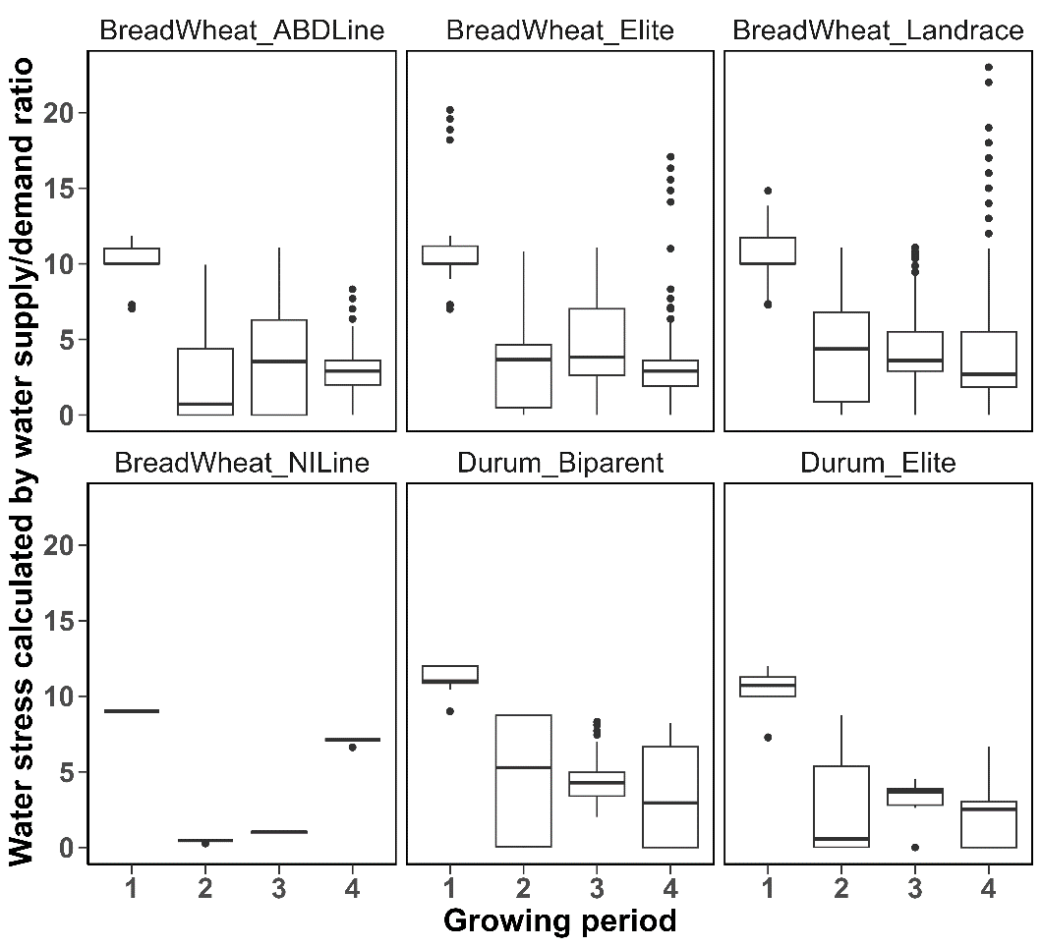
Figure 1. Boxplots of mean SDR (supply-demand ratio = water stress) for individual genotypes within six germplasm groups and for each of the growing periods (see text for details). Data includes all sowing times. The number of genotypes in each group and sowing time is given in Table 3.

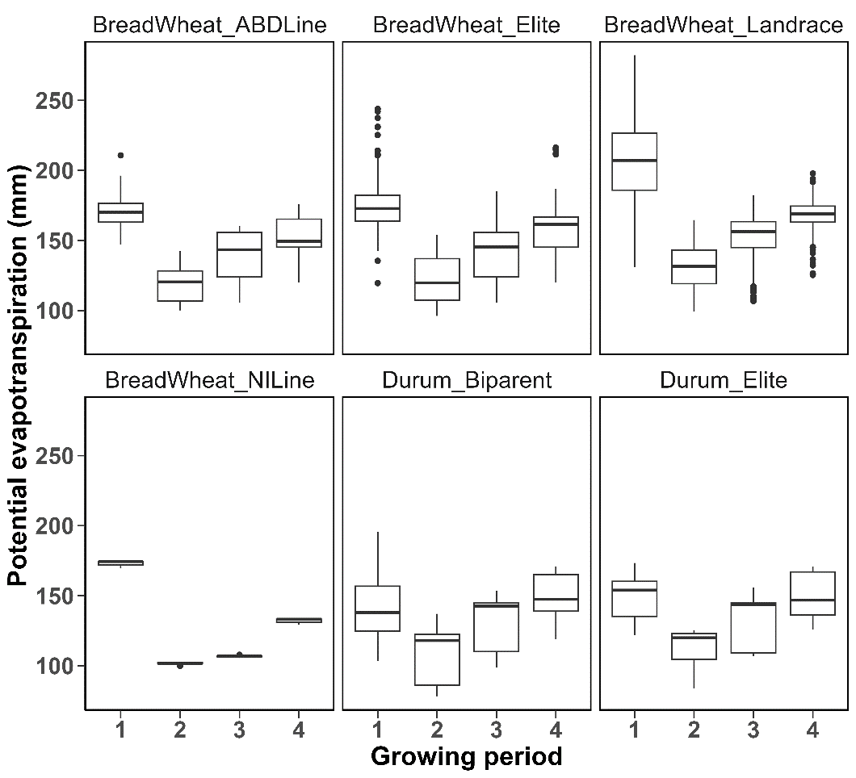
Figure 2. Boxplots of potential evapotranspiration for individual genotypes within six germplasm groups and for each of the growing periods (see text for details). Data includes all sowing times. The number of genotypes in each group and sowing time is given in Table 3.

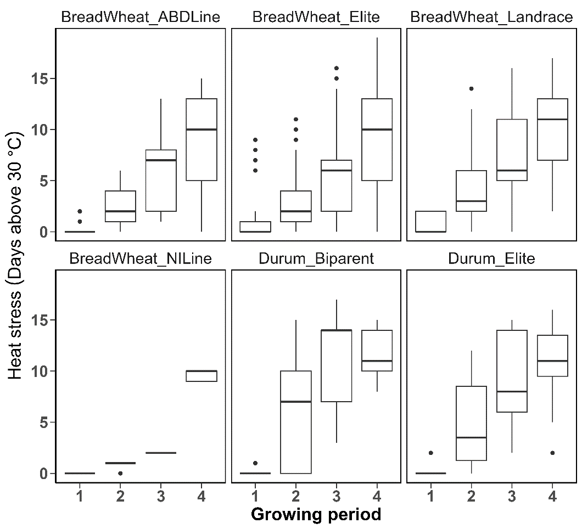
Figure 3. Boxplots of heat stress for individual genotypes within six germplasm groups and for each of the growing periods (see text for details). Data includes all sowing times. The number of genotypes in each group and sowing time is given in Table 3.

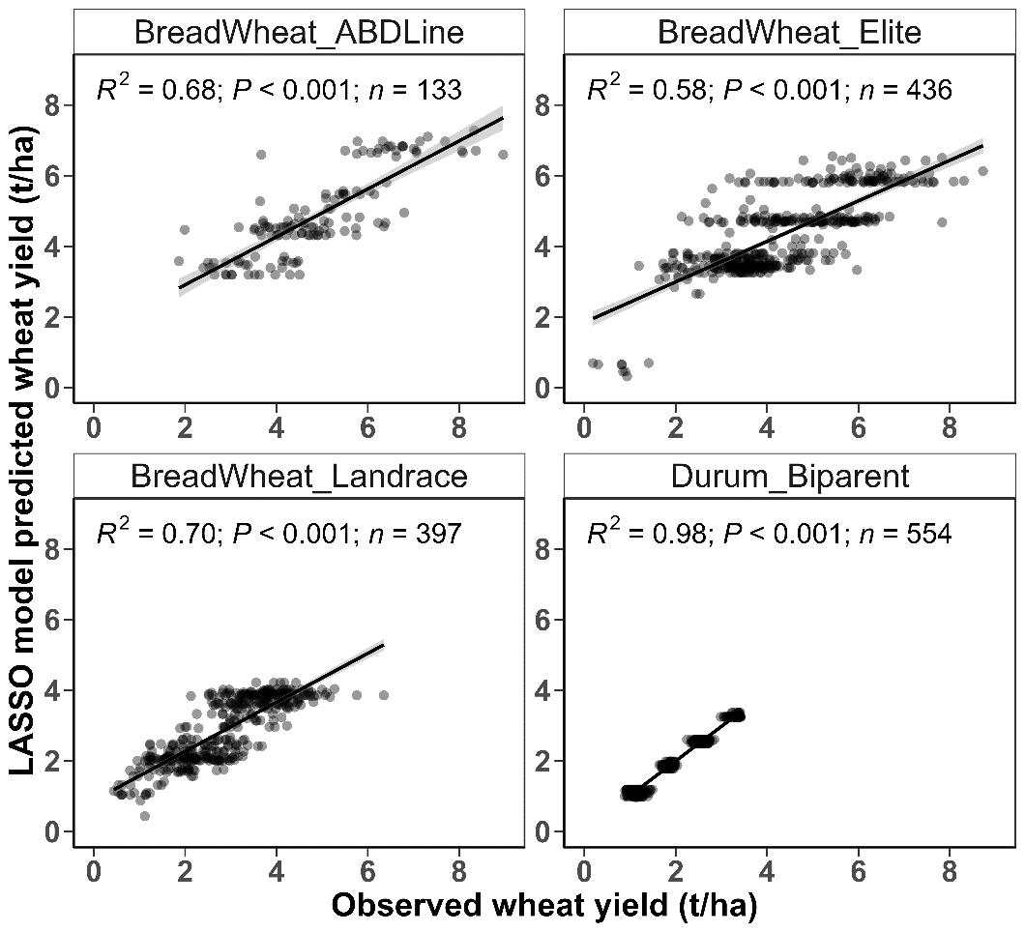
Figure 4. Plots of predicted wheat yield (t/ha) derived from LASSO modelling against observed yield for four wheat germplasm categories. The best fitted straight line, together with the R² and P-value of the slope term, are provided for better visual assessment.

Supplementary material for:

LASSO regression used for influential feature selection amongst many evapotranspiration, heat-stress and water-deficit variables when predicting yield in bread and Durum wheats from different germplasm groups

Muhuddin Rajin Anwara, Livinus Emebiri, Ryan H. L. Ip, David J. Luckett, Yashvir S. Chauhan, Ketema T. Zeleke

Table S1. The frequencies of concurrence of genotypes between the various “Situations”, where “Situation” consists of the combination of three factors: Site_Year_Sowing-time. The diagonal of the table gives the total genotype number tested in each Situation. The “Exotic” Durum wheat category has been excluded from this table as it was comprised of only 1 genotype.
Situation | LEETON_2011_1 | LEETON_2011_2 | LEETON_2015_1 | LEETON_2015_2 | WAGGA_2012_1 | WAGGA_2012_2 | WAGGA_2018_1 | WAGGA_2018_2 | WAGGA_2019_1 | WAGGA_2019_2
LEETON_2011_1 | 205 | 200 | 11 | 0 | 188 | 190 | 2 | 1 | 1 | 1
LEETON_2011_2 |  | 207 | 11 | 0 | 191 | 194 | 2 | 1 | 1 | 1
LEETON_2015_1 |  |  | 17 | 0 | 17 | 17 | 0 | 0 | 0 | 0
LEETON_2015_2 |  |  |  | 8 | 0 | 0 | 0 | 0 | 0 | 0
WAGGA_2012_1 |  |  |  |  | 263 | 263 | 2 | 0 | 0 | 0
WAGGA_2012_2 |  |  |  |  |  | 268 | 2 | 0 | 0 | 0
WAGGA_2018_1 |  |  |  |  |  |  | 134 | 71 | 71 | 71
WAGGA_2018_2 |  |  |  |  |  |  |  | 163 | 163 | 163
WAGGA_2019_1 |  |  |  |  |  |  |  |  | 163 | 163
WAGGA_2019_2 |  |  |  |  |  |  |  |  |  | 163

Table S2. Details (means and ranges) of the “sowing-date to flowering-date interval” (in days) for the genotypes within each germplasm category and across all combinations of Site, Year, and Sowing-time (1 = ‘early’, 2 = ‘late’).
Germplasm category | Site | Year | Sowing  time | Number of genotypes | Mean sowing to flowering interval (days) | Range in sowing to flowering interval (days)
BreadWheat_ABDLines | Leeton | 2011 | 1 | 28 | 114.8 | 110.5 – 120.0
BreadWheat_ABDLines | Leeton | 2011 | 2 | 28 | 84.2 | 79.3 – 86.7
BreadWheat_ABDLines | Leeton | 2015 | 1 | 11 | 129.6 | 127.7 – 130.6
BreadWheat_ABDLines | Wagga Wagga | 2012 | 1 | 33 | 122.7 | 117.3 – 133.4
BreadWheat_ABDLines | Wagga Wagga | 2012 | 2 | 33 | 84.5 | 79.7 – 90.7
BreadWheat_Elite | Leeton | 2011 | 1 | 98 | 116.7 | 110.1 – 136.4
BreadWheat_Elite | Leeton | 2011 | 2 | 97 | 85.7 | 77.7 – 98.0
BreadWheat_Elite | Leeton | 2015 | 1 | 6 | 130.2 | 128.5 – 132.0
BreadWheat_Elite | Leeton | 2015 | 2 | 8 | 104.4 | 101.7 – 106.1
BreadWheat_Elite | Wagga Wagga | 2012 | 1 | 111 | 124.2 | 116.9 – 137.5
BreadWheat_Elite | Wagga Wagga | 2012 | 2 | 114 | 85.5 | 72.9 – 95.7
BreadWheat_Elite | Wagga Wagga | 2018 | 1 | 2 | 138.6 | 137.1 – 140.1
BreadWheat_Landraces | Leeton | 2011 | 1 | 77 | 133.0 | 112.6 – 148.2
BreadWheat_Landraces | Leeton | 2011 | 2 | 80 | 94.2 | 83.3 – 107.9
BreadWheat_Landraces | Wagga Wagga | 2012 | 1 | 119 | 134.0 | 115.5 – 148.1
BreadWheat_Landraces | Wagga Wagga | 2012 | 2 | 121 | 91.1 | 76.0 – 107.8
BreadWheat_NILines | Wagga Wagga | 2018 | 1 | 61 | 139.5 | 137.7 – 140.5
Durum_Biparent | Wagga Wagga | 2018 | 1 | 71 | 138.1 | 137.3 – 138.9
Durum_Biparent | Wagga Wagga | 2018 | 2 | 161 | 90.2 | 87.9 – 94.4
Durum_Biparent | Wagga Wagga | 2019 | 1 | 161 | 115.6 | 109.6 – 120.3
Durum_Biparent | Wagga Wagga | 2019 | 2 | 161 | 77.3 | 72.4 – 82.5
Durum_Elite | Leeton | 2011 | 1 | 2 | 115.6 | 113.4 – 117.8
Durum_Elite | Leeton | 2011 | 2 | 2 | 83.0 | 81.3 – 84.7
Durum_Elite | Wagga Wagga | 2018 | 2 | 2 | 89.8 | 88.7 – 90.8
Durum_Elite | Wagga Wagga | 2019 | 1 | 2 | 116.4 | 116.3 – 116.4
Durum_Elite | Wagga Wagga | 2019 | 2 | 2 | 77.7 | 77.6 – 77.7

