Navigating Career Pathways: Insights from Education, Psychology, and Technology
Sara Ghafoor¹; Mahsa Mohaghegh².
Auckland University of Technology
Corresponding Author Email: mahsa.mohaghegh@aut.ac.nz
ABSTRACT
CONTEXT
High school students' career decisions are influenced by numerous factors, including traditional advising methods, parental influence, and the complex considerations of advisors. Social cognitive elements, extracurricular activities, job security, STEM challenges, and family influence are pivotal in shaping students' career trajectories. Recent advancements have introduced artificial intelligence into career guidance, offering accessible and personalised support. This review aims to explore the evolving landscape of career decision-making for high school students.
GOAL
The motivation behind this study is to examine the effectiveness of AI in enhancing career guidance for high school students. By analyzing various AI models, the study seeks to understand how AI can predict student career paths and the potential benefits of its implementation. The goal is to provide insights that can inform educators, counselors, and policymakers about the transformative potential of AI in career guidance.
METHODOLOGY
This systematic literature review involved collecting and analyzing data from existing studies on high school students' career decisions and the application of AI in career guidance. The review focused on models like Artificial Neural Networks and Multimodal Machine Learning to evaluate their predictive accuracy and practical utility. Ethical considerations and potential risks associated with AI implementation were also examined to provide a comprehensive understanding of the topic.
OUTCOMES
The review highlights the effectiveness of AI models in predicting career paths for high school students, demonstrating their potential to offer personalised and accessible career guidance. It also identifies significant ethical considerations and risks that need to be addressed. These insights contribute to a nuanced understanding of career decision-making and the role of AI in this process.
CONCLUSIONS
The study concludes that AI has the potential to transform career guidance by providing personalised support and improving the accuracy of career path predictions. However, ethical concerns and risks must be carefully managed. These findings offer valuable implications for educators, counselors, and policymakers, emphasizing the need for further research and discussion in the fields of education, psychology, and technology.
KEYWORDS
Career Guidance, High School Students, Artificial Intelligence.

Introduction
Career decisions are crucial milestones in an individual’s early life, particularly during adolescence when identity formation plays a key role. According to Erikson’s theory, identity development is closely tied to career choices, with this process intensifying during adolescence as individuals explore and solidify their professional paths (Erikson, 1968). However, career guidance programs often fall short in helping students make informed decisions that align with their abilities, knowledge, and aspirations (Crişan et al., 2015). As decision-making is influenced by factors such as personal experiences, suggestions, and external environments (Ho et al., 2018), traditional quantitative approaches have yet to fully capture its complexity. Thus, improving career guidance remains essential, especially as student career prediction continues to be a vital area of research, addressing the challenges young adults face during this pivotal stage of their lives.

Purpose of the SLR
This systematic literature review (SLR) reviews studies from 1991 onward to explore factors shaping high school students' career advice and choices. It includes pre-1991 research to understand how influences have evolved and incorporates AI's expanding role in personalised career guidance. The review identifies literature gaps, offering insights for educators, counsellors, and policymakers. It bridges traditional and technological approaches, aiming to inspire further research and provide practical implications for career decision-making.
Methodology
In this SLR, we look at career advice for high school students, focusing on the following research questions. The papers primarily focus on studies from 1991 to 2024. Only three pivotal papers from before this time were added to this literature. Following is the research question answered in this paper.
RQ: How can AI enhance personalised career guidance to address the limitations of traditional methods that often fail to adapt to individual skills, interests, and the evolving job market?
The review aims to offer valuable insights and perspectives in career advising.

Research Process
Out of 150 initially considered papers, 10 duplicates were removed, and 30 were flagged as ineligible by automation tools. Five additional papers were excluded for various reasons. After screening 105 papers, 28 were excluded due to quality or language issues. Two papers were not retrieved, leaving 77 papers. Of these, 32 were deemed irrelevant (e.g., gender-based studies). Ultimately, 43 studies were included in this review as shown in the Figure 1.
We collected scholarly articles from ACM Digital Library, IEEE, ScienceDirect, Scopus, and Springer, supplemented by Google Scholar searches. Keywords like "career advice," "machine learning," "high school students," "AI," and "career counselling" guided the initial search, with English language and date filters from 1991 onwards. Visualizations of these keywords were created using VOS viewer as shown in Figure 2.

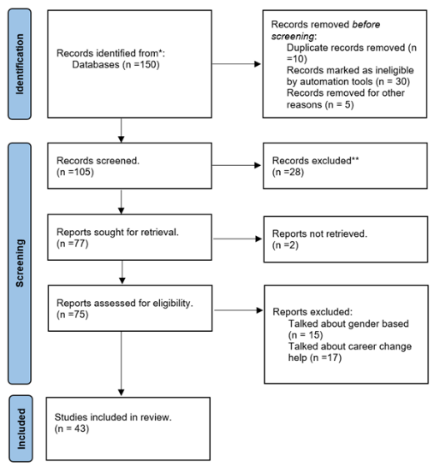
Figure 1: Systematic literature review process

Criteria for Inclusion/Exclusion
Our study reviewed research from 1991 to 2024 on factors influencing career choices and AI techniques, excluding papers on geography, school attendance, mentorship, gender-specific professions, and those lacking sufficient detail.

Evolving Methods of Career Guidance: Traditional and Modern Approaches
Career guidance has undergone significant evolution, blending traditional methods with modern approaches to meet the ever-changing demands of today's workforce. The traditional three-step model, consisting of self-exploration, occupational exploration, and self-occupation comparison, was developed over a century ago and has been widely utilized (Lent & Brown, 2020). However, it now faces limitations in addressing the complexities of modern career paths, which require integrating cognitive psychology, comprehensive assessments, and preparation for career disruptions.
Despite these advancements, personalized career guidance remains a cornerstone of effective career planning. Advisors provide crucial support in career exploration, vocational choices, and personal development by helping individuals analyze their skills, align goals, and assess personality traits (Varghese & Mohaghegh, 2023). One tool, the Career Style Interview (CSI), is known for enhancing self-awareness and confidence, but it requires further quantitative research to assess its broader applicability (Rehfuss et al., 2011).
In the realm of career advice, students often begin by relying on informal sources, such as family members or peers, but as they advance in age and education level, they tend to seek more structured guidance from professionals. (Witko et al., 2005) found that this transition plays a crucial role in students' career development, shifting their reliance from friends and family to teachers, advisors, and career counsellors. This progression highlights the growing need for formalized, personalized career support as students approach critical career decisions. In the domain of informal career guidance, mentorship plays a pivotal role. A qualitative study of deaf graduates from the Rochester Institute of Technology underscores the importance of mentors—whether family members, teachers, or supervisors—in shaping career success (Foster & MacLeod, 2004). Similarly, parental involvement can significantly influence adolescents’ career preparation, with support fostering career exploration, and interference creating decision-making challenges (Dietrich & Kracke, 2009).
The rise of technology has further transformed career advising. Early computer-assisted career planning systems emerged in the 1960s, based on strong theoretical frameworks, and remain effective tools for guiding career choices (Harris‐Bowlsbey, 2013). These systems have been shown to positively impact students’ educational and career trajectories, particularly when coupled with facilitator support. However, financial constraints limit their widespread use in the U.S., though they hold great promise for developing countries.
AI is now reshaping career advising, offering cost-effective and personalized guidance through machine learning. Instead of relying on traditional, lengthy questionnaires, AI-driven systems streamline career decision-making processes, particularly in helping students choose college majors (Kiselev et al., 2020; Wang et al., 2024). This shift signifies the future direction of career guidance, where both human and technological support work together to deliver more accurate, tailored advice.

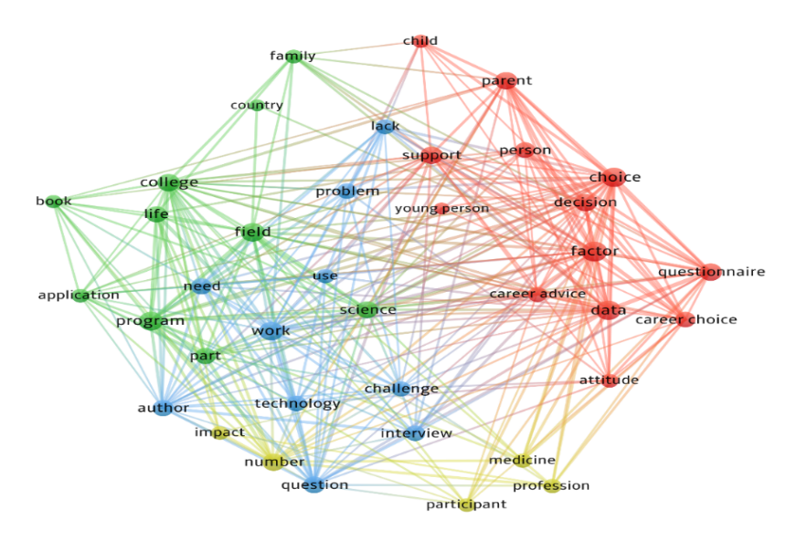
Figure 2: Identification of keywords for Career Advise using VOS viewer software.

Factors Considered while Career Advising
This section explores the various factors influencing high school students' career decisions. Table 1 summarises these factors, highlighting the complex interactions of social, personal, and environmental elements, with references to relevant studies.

Table 1: Summary of Factors Influencing High School Students' Career Decision
Factor | Summary | Reference
Social Cognitive Career Theory | Individuals shape career choices by observing role models, focusing on self-efficacy, expectations, interests, and goals. | (Choi et al., 2012)
Extracurricular Activities | Activity participation boosts job exploration and reduces career uncertainty, with arts and sociocultural pursuits having a positive impact. | (Denault et al., 2019)
Job Security | Job security varies by culture; German youth prioritise it more than Croatian youth. | (Wüst & Šimić, 2017)
STEM Career Challenges | STEM students struggle with specific job options, challenging traditional surveys. | (Dorph et al., 2018; Shahid et al., 2022)
Humanitarian Motivations | Medical careers are driven by helping others, personal satisfaction, and societal need, not strongly linked to academic success. | (Shahid et al., 2022)
Cultural Differences in Career Preferences | Westerners value personal interests, Asians prioritise practicality. Americans focus on creativity, while Chinese students emphasise job interest. | (Elizur et al., 1991; HASLETT & LEIDEL, 2015; Tang et al., 1999)
Family Influence | Family significantly influences career choices, with support decreasing as students age. Family factors, including occupations, are crucial during education. | (Buhl et al., 2018; Vautero et al., 2020)
Academic Performance | School performance, especially in Math and English, shapes career preferences. | (Hoff et al., 2022; Moriyasu & Kobayashi, 2022)
Anxiety in Career Decisions | Anxiety affects career choices, particularly in education and law, with entrance exam stress influencing decisions. | (Moriyasu & Kobayashi, 2022)
Personal Characteristics | Extraversion, Conscientiousness, and Openness guide careers; Neuroticism etc. less. | (De Jong et al., 2019)

Table 1 highlights how social cognitive factors, extracurricular activities, family influence, and cultural nuances shape students' career paths. Key elements include the impact of extracurricular engagement on career clarity, cultural differences in job security priorities, and the role of family support. Academic performance and personality traits also significantly affect career decisions, emphasizing the complexity of career counselling.

AI in Career Guidance
AI presents a transformative shift in career guidance by offering more accessible and personalized recommendations compared to traditional methods, which often rely on the involvement of parents, advisors, and mentors. Students can leverage AI to identify their strengths and weaknesses, compare their skill sets to specific career requirements, and receive tailored suggestions for studies, thesis topics, and job opportunities. This empowers them to actively manage their own career planning (Westman et al., 2021).
While the integration of AI into career counselling presents new opportunities, it also brings challenges. A notable study emphasizes the need for interdisciplinary collaboration to overcome obstacles in effectively incorporating AI into career guidance systems (Muhammad, 2023). This research highlights the strength of AI, particularly Artificial Neural Networks (ANN), in delivering personalized career recommendations. However, further exploration is necessary to identify the most optimal AI models for broader application in this field.
AI presents a transformative shift in career guidance by offering more accessible and personalized recommendations compared to traditional methods, which often rely on the involvement of parents, advisors, and mentors. Students can leverage AI to identify their strengths and weaknesses, compare their skill sets to specific career requirements, and receive tailored suggestions for studies, thesis topics, and job opportunities. This empowers them to actively manage their own career planning (Westman et al., 2021).
While the integration of AI into career counselling presents new opportunities, it also brings challenges. A notable study emphasizes the need for interdisciplinary collaboration to overcome obstacles in effectively incorporating AI into career guidance systems (Muhammad, 2023). This research highlights the strength of AI, particularly ANN, in delivering personalized career recommendations. However, further exploration is necessary to identify the most optimal AI models for broader application in this field.
In recent years, numerous studies have expanded the spectrum of career possibilities through AI. As the need for intelligent systems capable of understanding individual personalities and proposing tailored career paths becomes more apparent, AI models are gaining traction as an essential tool in modern career advising (Rao et al., 2020). Further studies have emphasized the importance of social factors in AI-guided career counseling. For instance, (Kiselev et al., 2020) highlight the integration of social constructivism in machine learning, showing that social networks in psychology play a critical role in career guidance. Their research, confirmed by metrics like Area Under the Curve - Receiver Operating Characteristic (AUC-ROC), underscores the value of using AI to explore and validate social theories in guiding career choices, adding another layer of depth to AI's application in this domain.

Comprehensive Review of AI Models for Career Prediction
A review of the literature shows that AI has been increasingly utilized in career guidance, but the depth and breadth of research vary across studies. Among the papers reviewed, many focus on ANNs, Support Vector Machines (SVM), and Logistic Regression as effective tools for career prediction. The following are key examples from the reviewed literature:
- Random Forest in Job Selection Prediction: (Khan et al., 2023) applied machine learning, specifically Random Forest, to predict job suitability with a 92% accuracy based on data from 120 job holders. This method highlights how AI can assess diverse career paths based on historical data, providing job seekers with highly accurate recommendations for their future career choices.
- STEM Career Prediction Using Logistic Regression: (Liu & Tan, 2020) leveraged Logistic Regression with the ASSISTments dataset, automatically reformatting and enriching features to improve predictions for STEM careers. This study underscores the effectiveness of AI in narrowing down career pathways in specialized fields like STEM, which often involve complex competency requirements.
- Neural Networks for Academic and Vocational Guidance: (Zahour et al., 2020) conducted a comparative study of Neural Networks and other machine learning algorithms for academic and vocational guidance. The study found that Neural Networks, particularly for automatic RIASEC classification, significantly outperformed other methods, suggesting that AI can assist in both career counseling and academic orientation.
- Personality-Based Career Predictions Using ANN: (Rao et al., 2020) explored how ANN can be used to predict career paths based on personality traits using MBTI-based web questionnaires. This approach demonstrates how AI can align personal traits with career recommendations, offering a more individualized experience than traditional methods.
- SVM for Decision-Making in Higher Education Institutions (HEIs): (Nieto Acevedo et al., 2019) demonstrated the effectiveness of SVM in developing decision-making models for HEIs, particularly in addressing low graduation rates and academic outcomes. The SVM outperformed other models in making accurate predictions, showing how AI can also be applied to institutional-level career guidance.
The in-depth analysis of these AI models reveals that the integration of AI into career guidance is not a distant possibility but a current reality that is already reshaping the landscape of career advising. Artificial Neural Networks, Support Vector Machines, and Logistic Regression models have shown varying levels of success in predicting career paths, each with its own strengths, such as predictive accuracy, interpretability, and practical applicability. The inclusion of AI-driven methodologies in the career counselling domain is essential to meeting the evolving needs of today’s students and professionals.
However, further research is needed to refine these models, ensure that they are adaptable to different populations, and address ethical concerns. As AI continues to be integrated into the educational and career domains, a multidisciplinary approach will be necessary to ensure that these tools provide not just accurate predictions but also meaningful, actionable insights that empower individuals to make informed career decisions.

Figure 3, summarises the challenges in career decision-making, highlighting influential factors, traditional methods, and technological advancements. It reveals the limitations of traditional approaches and emphasises the need for a nuanced, tech-informed strategy, offering a comprehensive view of the complexities in career decision-making.
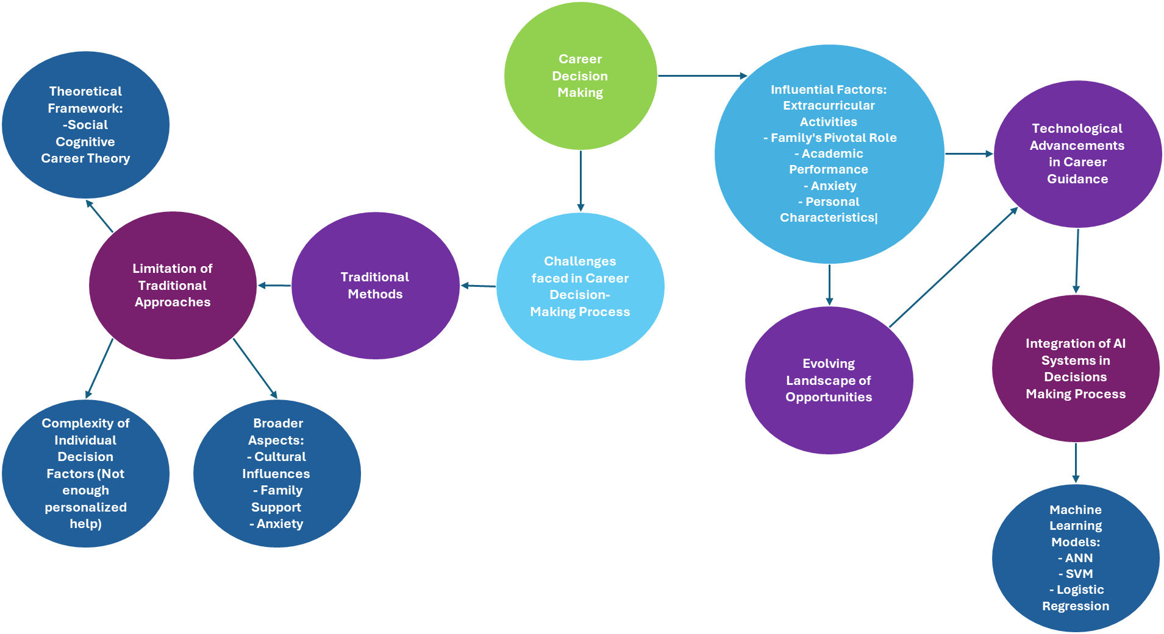
Figure 3: Interconnections Between Influential Factors, Challenges, Traditional Approaches, and Innovative Technologies

Discussion
This SLR highlights the evolving nature of career guidance, transitioning from traditional methods to AI-enhanced approaches. Traditional models, though foundational, often lack the personalized touch needed in modern career paths. AI has emerged as a promising tool, offering individualized career recommendations through machine learning and neural networks. The key takeaway is that AI, particularly models like ANN and SVM, holds potential to reshape career counselling by providing more tailored, data-driven insights.
However, challenges remain in integrating AI effectively. These include the need for interdisciplinary collaboration, ethical concerns, and ensuring adaptability across diverse student populations. While AI models have shown success in predicting career paths, their broader application requires further refinement.

Conclusion
In conclusion, AI is revolutionizing career guidance, offering precise, personalized recommendations that traditional methods cannot. The future of career advising lies in blending human expertise with AI's analytical capabilities, ensuring a holistic and adaptable approach. This review emphasizes the potential of AI-driven tools to empower students in making informed career choices while acknowledging the need for continuous research to address current limitations.

References
Buhl, H. M., Noack, P., & Kracke, B. (2018). The role of parents and peers in the transition from university to work life. Journal of Career Development, 45(6), 523-535.
Choi, B. Y., Park, H., Yang, E., Lee, S. K., Lee, Y., & Lee, S. M. (2012). Understanding career decision self-efficacy: A meta-analytic approach. Journal of Career Development, 39(5), 443-460.
Crişan, C., Pavelea, A., & Ghimbuluţ, O. (2015). A need assessment on students’ career guidance. Procedia-Social and Behavioral Sciences, 180, 1022-1029.
De Jong, N., Wisse, B., Heesink, J. A., & Van der Zee, K. I. (2019). Personality traits and career role enactment: Career role preferences as a mediator. Frontiers in psychology, 10, 1720.
Denault, A.-S., Ratelle, C. F., Duchesne, S., & Guay, F. (2019). Extracurricular activities and career indecision: A look at the mediating role of vocational exploration. Journal of Vocational Behavior, 110, 43-53.
Dietrich, J., & Kracke, B. (2009). Career-specific parental behaviors in adolescents’ development. Journal of Vocational Behavior, 75(2), 109-119.
Dorph, R., Bathgate, M. E., Schunn, C. D., & Cannady, M. A. (2018). When I grow up: The relationship of science learning activation to STEM career preferences. International Journal of Science Education, 40(9), 1034-1057.
Elizur, D., Borg, I., Hunt, R., & Beck, I. M. (1991). The structure of work values: A cross cultural comparison. Journal of Organizational Behavior, 12(1), 21-38.
Erikson, E. H. (1968). Identity youth and crisis. WW Norton & company.
Foster, S., & MacLeod, J. (2004). The role of mentoring relationships in the career development of successful deaf persons. Journal of Deaf Studies and Deaf Education, 9(4), 442-458.
Harris‐Bowlsbey, J. (2013). Computer‐Assisted Career Guidance Systems: A Part of NCDA History. The Career Development Quarterly, 61(2), 181-185.
HASLETT, B. B., & LEIDEL, K. (2015). Work Values in a Changing Global Environment: Comparing Chinese and US Students. Intercultural Communication Studies, 24(2).
Ho, C. C., Lee, H. L., Lo, W. K., & Lui, K. F. A. (2018). Developing a chatbot for college student programme advisement. 2018 International Symposium on Educational Technology (ISET),
Hoff, K. A., Chu, C., Einarsdóttir, S., Briley, D. A., Hanna, A., & Rounds, J. (2022). Adolescent vocational interests predict early career success: Two 12‐year longitudinal studies. Applied Psychology, 71(1), 49-75.
Khan, M. A. R., Paul, A. R., Rahman, F., Akter, J., Sultana, Z., & Rahman, M. (2023). Appropriate Job Selection Using Machine Learning Techniques.
Kiselev, P., Kiselev, B., Matsuta, V., Feshchenko, A., Bogdanovskaya, I., & Kosheleva, A. (2020). Career guidance based on machine learning: social networks in professional identity construction. Procedia Computer Science, 169, 158-163.
Lent, R. W., & Brown, S. D. (2020). Career decision making, fast and slow: Toward an integrative model of intervention for sustainable career choice. Journal of Vocational Behavior, 120, 103448.
Liu, R., & Tan, A. (2020). Towards interpretable automated machine learning for STEM career prediction. Journal of Educational Data Mining, 12(2), 19-32.
Moriyasu, R., & Kobayashi, T. (2022). Impact of career education on high school students’ occupational choice: Evidence from a cluster-randomized controlled trial. Japan and the World Economy, 63, 101146.
Muhammad, R. (2023). Barriers and effectiveness to counselling careers with Artificial Intelligence: A systematic literature review. Ricerche di Pedagogia e Didattica. Journal of Theories and Research in Education, 18(3), 143-164.
Nieto Acevedo, Y. V., García Díaz, V., & Montenegro, C. E. (2019). Decision-making model at higher educational institutions based on machine learning. Journal Of Universal Computer Science, 25.
Rao, A. S., Kamath, B. S., Ramya, R., Chowdhury, S., Shreya, A., & Pattan, R. K. K. (2020). Use of artificial neural network in developing a personality prediction model for career guidance: A boon for career counselors. International Journal of Control and Automation, 13(4), 391-400.
Rehfuss, M. C., Corso, J. D., Galvin, K., & Wykes, S. (2011). Impact of the career style interview on individuals with career concerns. Journal of Career Assessment, 19(4), 405-419.
Shahid, Z., Fatima, K., Siddiqui, F., & Panhwar, G. (2022). Association of career choice and motivation with academic performance. J Xi’an Shiyou Univ, 18(9), 125.
Tang, M., Fouad, N. A., & Smith, P. L. (1999). Asian Americans' career choices: A path model to examine factors influencing their career choices. Journal of Vocational Behavior, 54(1), 142-157.
Varghese, J., & Mohaghegh, M. (2023). Personality-Based Hybrid Machine Learning Model for Mentor-Mentee Matching using Collaborative and Content Filtering Methods. 2023 7th International Symposium on Multidisciplinary Studies and Innovative Technologies (ISMSIT),
Vautero, J., Taveira, M. d. C., & Silva, A. D. (2020). Family Influence on Career Decision Making: A Literature Review. Revista Brasileira de Orientação Profissional, 21(1), 17-28.
Wang, Y., Fu, E. Y., Zhai, X., Yang, C., & Pei, F. (2024). Introduction of artificial Intelligence. In Intelligent Building Fire Safety and Smart Firefighting (pp. 65-97). Springer.
Westman, S., Kauttonen, J., Klemetti, A., Korhonen, N., Manninen, M., Mononen, A., Niittymäki, S., & Paananen, H. (2021). Artificial Intelligence for Career Guidance--Current Requirements and Prospects for the Future. IAFOR Journal of Education, 9(4), 43-62.
Witko, K., Bernes, K. B., Magnusson, K., & Bardick, A. D. (2005). Senior high school career planning: What students want. The Journal of Educational Enquiry, 6(1).
Wüst, K., & Šimić, M. L. (2017). STUDENTS'CAREER PREFERENCES: INTERCULTURAL STUDY OF CROATIAN AND GERMAN STUDENTS. Economics & Sociology, 10(3), 136-152.
Zahour, O., Benlahmar, E., Eddaouim, A., & Hourrane, O. (2020). A comparative study of machine learning methods for automatic classification of academic and vocational guidance questions.

Copyright statement
Copyright © 2024 Sara Ghafoor, Mahsa Mohaghegh: The authors assign to the Australasian Association for Engineering Education (AAEE) and educational non-profit institutions a non-exclusive licence to use this document for personal use and in courses of instruction provided that the article is used in full and this copyright statement is reproduced. The authors also grant a non-exclusive licence to AAEE to publish this document in full on the World Wide Web (prime sites and mirrors), on Memory Sticks, and in printed form within the AAEE 2024 proceedings. Any other usage is prohibited without the express permission of the authors. – TO BE INSERTED BY THE AUTHORS AFTER REVIEW AND BEFORE THE FINAL SUBMISSION

