[pre-publication – accepted for publication]

Untethered: Resisting unhelpful assumptions about news trust and trust in other social institutions
Greg Treadwell, Auckland University of Technology
Merja Myllylahti, Auckland University of Technology
Corresponding author: Dr Greg Treadwell | Auckland University of Technology | PO Box 9206, Wellesley St, Auckland, 1081, NZ | gregory.treadwell@aut.ac.nz | +64 21 921 092

Acknowledgements
Our research into news trust at AUT is carried out in association with the Reuters Institute for the Study of Journalism, at the University of Oxford.

Ethical considerations
This research was approved by the Auckland University of Technology Ethics Committee; ref: 24/56

Consent for publication
We confirm informed consent for publication was provided by the participants.

Conflicts of interest
The authors declare no potential conflicts of interest exist with respect to the research, authorship, and/or publication of this article.

Funding statement
Funding for this research came from the Centre for Journalism Media and Democracy, at Auckland University of Technology.

Abstract
A focus on the falling levels of trust in news in many liberal democracies has emerged in journalism studies because trust is considered a core part of journalism’s infrastructure and necessary if it is to fulfil its democratic duties. In both the academic and grey literature, trust in news is often connected with trust in other societal institutions, including governments, politics, businesses and non-governmental organisations. This study investigates, through a lens of social-contract theory, the extent to which we can be confident that trust in news is directly connected to trust in government and politics, and to trust in other social institutions. Using a general-elimination method, we compare trends in trust-based social relationships to see which connections between trust in the news and public institutions should be retained in future studies. To help identify these (dis)connections, we also explore mixed-methods data about news trust from a longitudinal in Aotearoa New Zealand. Our findings suggest trust in news is connected to changes in trust in other social institutions but is not tethered to them. This indicates we cannot encouraging exploration of bespoke solutions for trust issues facing public-interest journalism. We argue trust in journalism is not on an inevitable downward trajectory because most or all social institutions are, and that strengthening the visibility of core journalism values such as factuality, and creating less distressing storytelling would help arrest the slide.

Introduction
As public scepticism of social and political institutions grows across liberal democracies (Brady & Kent, 2022), falling public trust in the news media is often conflated in research with falling trust in social institutions in general, including government, business and non-governmental organisations (NGOs). The public, such research suggests (e.g. Lewis, 2018, p. 45), mistrust all social institutions, journalism included. However, this broad sociological approach risks overshadowing the special relationship between journalism and its audiences, foregrounding as it does the institutional nature of news. Such an approach is valuable for understanding democratic institutions and the issues they face today, but it generalises across social realms. In this article, we set out to see if journalism is in the same boat as the others or if it had specific contexts that might be addressed separately. This study deploys social-contract theory to locate the role of journalism as an enabler of the general social contract and its relationship to the wider web of citizens, groups and social institutions. It asks, is the decline in news trust simply part of declining trust in democratic social institutions in general or does journalism have its own set of issues that might be addressed? To differentiate journalism’s public-trust issues, this study explores ways in which falling trust in news in Aotearoa New Zealand is or isn’t linked to declines in trust in other social institutions, primarily government, business and non-governmental organisations (NGOs). Set against findings from a five-year longitudinal survey of New Zealanders’ trust in, and attitudes to, the news, the research also explores data from two groups of New Zealanders who distrust the news. This study also compares publicly available benchmark studies on public trust in social institutions, including the news, in both Aotearoa New Zealand and global contexts. It uses a pragmatic elimination method to categorise trust (dis)connections related to news media and to other social institutions, and finds that while trust in news may be related to trust levels in other social institutions – and in some cases should be – it is not tethered to those levels and does not mirror rises and falls in trust in government, business and NGOs.

Journalism’s social contract
The public pact between journalism and its audiences has been central to normative ideals of open society. This relationship – the social contract of the press – has been widely accepted as a necessary, if not sufficient, prerequisite for any level of actually existing democracy, and, indeed, journalism surrounds itself with “this type of borrowed [democratic] discourse” (Sjøvaag 2010, p. 876). Characterised as a social contract built on trust, the relationship between journalists and the public both mirrors and inhabits the broader social contract that binds institutions and orders society in (relatively) peaceful and productive ways (Sjøvaag, 2010). Still central to ideas of a general social contract, though not universally, is Hobbes’ proposition (2008) that to avoid brutal and desolate survivalism, a generalised social contract prioritises co-operation between individuals and groups, creating opportunities for social, economic and cultural enterprises that come with both rights and responsibilities. In a democracy, though not exclusively, such socio-political success depends on an open and public exchange of high-quality information between the contracted partners. This enables knowledge to be shared and trust among citizens and institutions to be built. In ideological terms, from the absolutism of Hobbes to the collective ideals of Habermas, democracy theory has been shaped by its need for such a public realm. Journalism, despite its seemingly irrevocable flaws, has structured such a sociopolitical space. Without it, the ideal of an informed public can only be inadequately realised. Trust is thus core to the infrastructure of journalism (Moran and Nechushtai, 2023, p. 462) and essential for an open society.

It is highly contestable, of course, that these ideas of journalism’s role in democracy have solely, or even primarily, shaped today’s news and its relationship to its publics. Not only is journalism now accepted as a set of cultural practices among which its political role is just one, but as Zelizer (2012) argues, democracy theory has long played too strong a role in journalism studies, skewing things as it outlived its scholastic shelf-life primarily because so much institutionalised knowledge depended on it. This apparently unavoidable democracy-journalism nexus has been “often unreflective of circumstances beyond the West” (p. 465). Nevertheless, there is still a direct line from liberal-democracy theory to the idea of the news media as a key monitor of political power. A social contract that binds journalism and its audience remains a conceptual and concrete necessity (Moran and Nechushtai, 2023) if the ambitions of a political democracy are to remain potent. Hence, we examine issues of news trust through a social-contract lens, allowing access to a field comprising trust-based relations between the public and social institutions, including news. The social contract of the press is a contract between the public and the news media that must be accepted by a state wanting democratic legitimacy. Sjøvaag notes this relationship establishes journalism as “a separate contractual partner with a mission to sustain the democratic order as it is expressed in the original political-philosophical social contract” (2010, p. 874). The social contract between journalism and its audiences helps structure the wider social contract, given its centrality as a functionary. It gives journalists authority to inform the public on democratically significant matters and, in theory, it gives audiences the ability to trust journalists to put public interest at the forefront of their work. Thus, journalism’s social contract underpins its role in democracy, primarily its obligations to inform the public and scrutinise government (Sjøvaag, 2018, p. 1). In this triangle of relationships, the trustworthiness and legitimacy of the news media “ultimately rests on its fulfilment of its social contract obligations towards the citizenry more so than on its obligations to the state” (Sjøvaag, 2010, p. 855). Pickard (2021) notes the privileges news media have depend on how well they serve the public and democracy and fulfil their public-service role. If they fail in their obligations, it “will result in termination of the contract and even potential punitive measures” (2021, p. 325). Hence, we bring a social-contract lens to this study because trust in news, however diminished, is still the lifeblood of actually existing democracy.

Trust as a social foundation
Trust is an “important basis for social order and a foundation for social cohesion” (Kohring & Matthes, 2007, p. 231) and extends across all social planes. Trust helps structure the socio-cultural world; positive levels of trust help stabilise social relationships, despite inequalities and asymmetrical power relations among groups. However, trust as a social phenomenon is hard to define (van den Bos, 2023, p. 288; Moran & Nechushtai, 2023) and tricky to measure (Prochazka & Schweiger, 2019). Trust is a relational link between trustor and trustee in a future-oriented, potentially productive partnership. The investment of trust by parties to the relationship is aimed at advancing the interests of each, be they the same or different. (Prochazka & Schweiger, 2019, p. 27).

Trust also exists between individuals and various organisations and socio-political structures, including government, political parties and politicians, corporations, educational institutions, NGOs, and other such entities. These institutions play a vital role in shaping public policy, maintaining social order, holding the State to account, and providing essential services to citizens. A trusting public believes to significant levels these entities will act in its interests and uphold their responsibilities to it. Among these institutions is news, provided by both publicly owned and privately owned news organisations. We define trust in news as the confidence or belief individuals place in the accuracy, reliability, and impartiality of information presented by news organisations. In a democracy, a well-functioning news media plays a crucial role informing the public, helping shape public opinion, and holding public and other institutions, including itself, accountable. When people trust the news, they make informed decisions based on it, including those involving political participation.
However, after three decades of market- and technology-driven disruptions to the normative contexts of public-interest journalism, audiences in many countries now consistently report very low and/or declining levels of trust in news (Newman et al., 2023; Myllylahti & Treadwell, 2024). A wave of trust-related research has emerged in response (e.g., Fisher, 2016; Usher, 2018; Lewis, 2019; Fink, 2019; Engelke et al, 2019; Kalogeropoulos et al., 2019; Newman, et al., 2024, Prochazka & Schweiger, 2019; Strömbäck et al, 2020; Toff et al., 2021; Moran and Nechushtai, 2023). Not every country is experiencing such a loss in news-trust, however, and there are marked differences between markets that are experiencing it (Hanitzsch et al., 2018; Newman, et al., 2024). Indeed, in 2023, general trust in news recovered in some markets, including in the United States and Finland, but the downward trend continued in many Western media markets, including the UK, Germany and New Zealand (Newman et al., 2023; Myllylahti & Treadwell, 2024). In 2024, trust in news globally stabilised at 40% (Newman et al., 2024).

In Aotearoa New Zealand, where this study took place, public trust in news has been falling even more rapidly than in broadly comparable countries, such as Australia, the United Kingdom and the United States of America (USA). Between 2020 and 2024, the number of New Zealanders who trusted the news in general fell 20 percentage points (pp) from 53% to 33%, now only just ahead of the USA at 31% (Myllylahti & Treadwell, 2024). Finland, by comparison, leads the world’s liberal democracies, with 69% of the adult population still trusting the news (Reuters, 2023).
Commonly expressed reasons for distrusting news relate to perceptions of media bias, spin and political agendas. A significant proportion of the public “feels powerful people are using the media to push their own political or economic interests, rather than represent ordinary readers or viewers” (Newman & Fletcher, 2017, p. 5). Other reasons relate to perceived qualities of the journalism, including the blurring of clear boundaries between news content and opinion (Myllylahti & Treadwell, 2021, p. 9).

Trust in news is theoretically and empirically connected to other stores of political and social trust. Banjeree et al. (2023) observe that people’s trust in the news and news media is linked to social, political and cultural aspects of their community. In the Global North and Global South, for instance, “different demographic segments have distinctly different relationships with civic institutions, which shapes people’s expectations towards news media as an institution as well” (p. 68). More specifically, declines in trust in news have been linked elsewhere to low trust in politicians and governments, in medical establishments, in scientists and so on. More recently they have been linked to the emergence of social-media platforms, alternative-media sites, fake news and disinformation, and to a lack of news diversity and the underpresentation of the voices of marginalised groups (Andersen et al., 2023; Arguedas et al., 2023; Hameleers et al., 2022; Newman et al., 2019). During the Yellow Vests protests in France in 2018, for example, trust in the news plummeted when the news media was perceived by many to align itself with the political elite, and be contributing to the polarisation of society (Newman et al., 2019). Hanitzch et al. argue a “growing anti-elitist sentiment in many societies, which has become a fertile ground for populist political movements” (2018, p. 18) is in part behind the erosion of trust in news media. Research has shown during and after the Covid-19 pandemic, some people became alienated from the news, perceiving it as failing to challenge government policy on vaccinations and public-safety mandates. On the other hand, changes in the political or societal landscape can sometimes positively correlate with trust in news. For example, the Reuters Digital News Report 2023 shows that trust in news in the United States increased 6% in 2023 from the previous year to 32% as politics became “a bit less divisive under Joe Biden’s presidency” (Newman et al., 2023, p. 25).

Hanitzsch et al. (2018) argue that a lack of trust in Government is one of the key issues linked to the trust in news media. They observe that the political environment plays an important role in the formation, maintenance or decline of trust in the news. More specifically, news-media trust and political trust seem to be connected in an upward spiral in some countries and a downward spiral in others. Their multilevel analysis shows decline in news-trust may “go hand in hand with a decline in political trust or even a more general disenchantment with social institutions” (2018, pp. 4–5). In this case, the public’s trust in news media is not isolated from its perceptions of other public institutions. The loss of news-trust across many democratic societies threatens the future of journalism as a social institution and, by implication, the integrity of such democacy, dependent as it is on well-informed discourse among voters. Lewis (2018) notes that one reason for the lack of trust in press is an institutional weakness that hinders journalists from completely fulfilling their normative function in a society. He notes that people’s distrust of the media is largely linked to the “changing structural conditions – technological, economic, political – that in turn are reshaping the roles, routines, and revenue models of news organizations” (Lewis, 2018, 45). Trust in social media, where news is now often consumed, is also connected to trust in news content. News is increasingly and fleetingly encountered on vast social-media platforms, meaning opportunities for “meaningful, habitual relationships with the public – the foundation, we think, for lasting trust – become few and far between” (Banerjee et al., 2023, 68).

Methodology
This exploratory study emerges from our interest in trust in news and societal institutions in Aotearoa New Zealand. While the country’s media market is relatively small, it has similar characteristics to the North Atlantic and Western European media systems, and traditionally has experienced very little intervention by the State (Brüggemann et al., 2014; Hanusch & Hanitzsch, 2019; Myllylahti, 2023). It is comprised of both public broadcasters and private media corporations, with a growing independent news sector (Treadwell, 2023, p. 55). In ways comparable to other Western countries, the Aotearoa New Zealand journalism industry faces ongoing and potentially existential crisis of revenue and in 2024 and 2025 significant closures and job cuts in newsrooms have continued across legacy media.

Trust in news in Aotearoa New Zealand has fallen from 53% of people agreeing they “can trust most of the news most of the time” in 2020 to only 32% in 2025 (Myllylahti & Treadwell, 2025). Perceived political bias and opinion masquerading as news are key reasons given by the public for not trusting the news. This delineates trust issues in news-specific ways and raises questions about ongoing assumptions that the falls in news trust are directly tied to falls in trust in the wider field of social institutionalism. Having studies trust in news for more than five years, we were concerned these sociological connections might overshadow more specific reasons for the falls in news trust. Hence, for this study we asked the following research questions.

Research question: Where, if anywhere, can links be identified between the decline in trust in news and levels of trust in other social institutions in Aotearoa New Zealand?
Subordinate research question: To what extent, if any, can we assert that decline in trust in news is directly linked to declines in trust in politics and politicians?

To pursue answers to these questions, we explored primary data that included the results of an annual survey of public trust in news for a longitudinal study for the Centre for Journalism, Media and Democracy (JMAD) at Auckland University of Technology. For five years, the annual survey has produced opportunities to analyse both quantitative and qualitative data, exploring, among other things, given reasons for not trusting the news. Such primary data from our research is supplemented by secondary data, including the annual results of the Reuters Institute for the Study of Journalism’s Digital News Report. Our annual study is conducted in association with the Reuters Institute, with whom we share questions about news trust so we may make comparisons between Aotearoa New Zealand data and those from almost 50 other countries. For secondary data for this study, we also use the publicly available results of local and global research into trust in news, government, business and social institutions. This allows a comparison of the trajectories in news trust, both in Aotearoa New Zealand and globally, with the trajectories of trust in other social institutions.

Data sets
We used quantitative data from the global Edelman Trust Barometer and Acumen Edelman Trust Barometer New Zealand to describe the trajectories of levels of trust in media, business, government and NGOs. The data was collected between 2020 and 2023, although Acumen New Zealand data sets are only available for 2020 and 2022. We used publicly available OECD data and a 2022 survey from NZ Herald/Dynata to investigate trust in societal institutions in Aotearoa New Zealand. We acknowledge the range of methodologies and the different contexts in which these data sets have emerged and that this may limit the usefulness of the comparison. Nevertheless, we submit they are highly suitable for an indicative overview of trends in social trust, and the exploratory nature of this study. Quantitative data from Aotearoa New Zealand and global news markets (2020-2024) are presented statistically to build a picture of the state of public trust in social institutions and highlight patterns, co-relations or divergences. To be able to compare trust in parliament with news and other social institutions, including government, we used quantitative data from OECD and the New Zealand Parliament itself. These figures are from 2021 and 2023, with publicly available data about trust in Parliament relatively patchy. And to be able to compare the levels of trust in news with trust in other institutions, we drew on five years’ longitudinal data we have collected at JMAD. Each year since 2020, we have surveyed a nationally representative selection of New Zealanders about the levels of trust they say they have in the news (Myllylahti & Treadwell, 2020–2024). The data for this research has been collected for us by Horizon Research Ltd, a company specialising in online polling. The online survey is of more than 1000 New Zealand adults (18 years or over) who are members of Horizon Research’s HorizonPoll (adult general population), Horizon Research Māori (Māori, 18+ years) panels and a third-party 18+ panel. The sample is weighted on age, gender, highest educational qualification, personal income, ethnicity and region to match the New Zealand adult population. It has a maximum margin of error at a 95% confidence level of ±3% overall. Benchmarked against the Reuters Institute for the Study of Journalism’s annual Digital News Report, our study shows that in five years Aotearoa New Zealand has fallen from being near the top of a number of comparable countries to being near the bottom in terms of news trust (Myllylahti & Treadwell, 2020–2024).

Method of analysis
To investigate the extent to which trust in news is connected or disconnected to trust in other social institutions, we use a general elimination methodology (GEM), a theory-driven and qualitative method that “improves our understanding of cause-and-effect relationships by systematically identifying and then ruling out causal explanations for an outcome of interest” (General elimination methodology, n.d.). GEM takes a pragmatic approach to understanding causal relationships and is useful when approaches such as random-control testing are not available (Scriven, 2008). The method is deterministic and constructs a list of possible causes (LOPC) against the facts of the case, and explores the modus operandi of each, before eliminating those that do not stand up to scrutiny for causal integrity. Methods applicable to the approach include both direct critical observations, including those of case studies, and direct inductive inference. We employ GEM to help isolate, and identify, direct causal links between trust in news and other cases of socio-political trust. We aim to start to build a clear picture of the relationship between news trust and other cases of social trust. Expanding the “conceptual framework through which trust is assessed to consider its infrastructural role affords greater clarity on the consequences of distrust in news” (Moran & Nechushtai, 2022, p. 457).

Findings and Discussion
While the OECD has warned Aotearoa New Zealand faces social challenges, it says public governance in Aotearoa New Zealand is functioning well, and trust in others and in public institutions is comparatively high (2003). Figure 1, below, for which data are drawn from a 2022 national survey (Dyanta), shows still-strong levels of trust in a range of social agencies and actors in Aotearoa New Zealand. Among these, scientists and doctors are most trusted. Meanwhile, in Figure 2, data from the OECD reflect trust across five sectors in 2021: police, courts, public service, local politicians and media. Police were the most trusted (73%) and media in general (as opposed to news) the least (35%). Levels of trust in police, doctors, scientists and the courts arguably speak to a still relatively stable wider social contract, even if cracks might be appearing (Gluckman, et al., 2021).

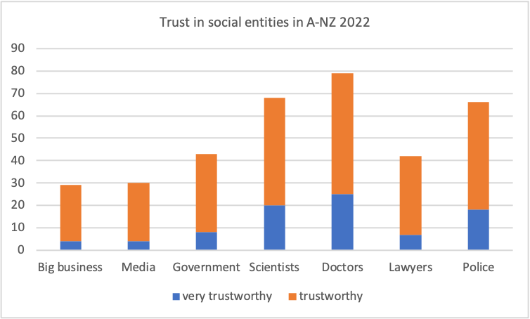
Figure 1. Trust in social, economic and political institutions in Aotearoa New Zealand. Source: NZ Herald, Dynata 2022

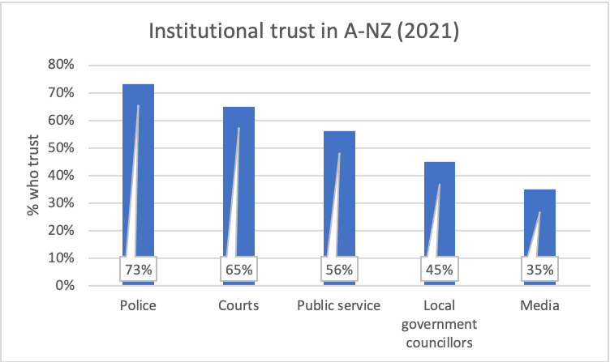
Figure 2. Institutional trust in Aotearoa New Zealand in 2021. Source: OECD

Falling levels of trust in news and media in these secondary data sets line up with the trends we have identified in our quantitative research in Aotearoa New Zealand. A primary finding has been a dramatic fall in those who say they have a general trust in news, from 53% of respondents in 2020 to 33% by 2024. Meanwhile, trust in the news New Zealanders chose to consume themselves fell from 62% in 2020 to 45% in 2024. Other significant trends identified include New Zealanders’ very strong interest in news but also their relatively high levels of news avoidance. In analysis of respondents’ written comments, we found those who did not trust the news and those who tended to avoid it said they found it overwhelmingly depressing, politically and commercially biased, and too opinionated (Myllylahti & Treadwell, 2024, p. 24).

Comparisons with trust in social institutions
Here we used GEM to help us eliminate those trust trajectories that do not clearly align with the trajectory of trust in news in some way. We were open to the idea that news media is seen by some, including some of those who mistrust news because they perceive it as politically biased, as simply part of the problematic establishment. If this was significant, for example, we might see trust in news rising and falling with, or at least influenced by, trust in government to some extent. We compared three trust trajectories with trust in news one by one: business, government and NGOs.

Trust in news/business
Trust in news in Aotearoa New Zealand in general fell 11% from 53% 2020 to 42% in 2023, while public trust in business grew from 54% to 58% in that same period (Table 1). Levels of public trust in news and trust in business were almost equivalent in 2020 but diverged significantly during and after the pandemic. It should be noted here data for levels of trust in government in 2021 were not available but went on to hit a peak in 2023 before falling slightly, leaving a relatively significant overall gain (4%). News, meanwhile was on a steady trajectory downwards, apparently not influenced by the waypoints that precipitated changes to the trajectory of trust in business. Within the possible purview, they appear unrelated, and we find trust in news does not mirror rises and falls in public trust in business. In line with GEM principles, we can eliminate the causes of trajectory changes in business trust as direct causes for trajectory changes in trust in news.

Trust in news/government
New Zealanders’ trust in government fell 4% from 2020 to 2023 to 51% (Acumen Edelman, 2023); it has been markedly higher than trust in news but also declining. Trust in Parliament reverted to pre-pandemic levels. See below for a fuller analysis as we approach our sub-research question about connections specifically between trust in news and trust in politics. In our analysis, we eliminate the fall in trust in government as causally linked to falling levels of trust in news.

Trust in news/NGOs
Meanwhile, trust in non-governmental organisations (NGOs) over the same period grew by 3% to 55%, having been as high as 57% in 2022. News, by comparison fell 11% to 42%. Here, NGOs are understood to have a watchdog role as part of a “monitory democracy” (Keane, 2011), and certainly large numbers of them monitor the State in own sector, at least at the levels of funding and policy. As trust in them has grown, trust in news nevertheless continued to fall, and we can confidently eliminate the changes in trust in NGOs as tethered to falling trust in news.

We compared trust in news with trust figures for these three sectors because they are central to the wider social contract and so potentially connected to trust in news. These figures are shown in Table 1. The trends for each are plotted over four years in Figure 3. In general trust in news has fallen relatively steadily on a downwards trajectory over four years, from 53% in 2020 to 42% in 2023. Meanwhile, the other three have taken courses parallel to each other to a significant extent and entirely different to that of news. They all peak in levels of trust in 2022 before falling somewhat in 2023 (see Fig. 3). Trust in NGOs and trust in business both ended the period higher than they started but also peaked and fell after 2022. Trust in government ended 4% lower than where it began, with its highest of 57% in 2022. Trust in news, however, did not enjoy the same lift as business in 2022. Rather, as reflected in Figure 3, trust in news appears to have been on a course of its own.

Table 1. Trust in news and other social institutions in Aotearoa New Zealand
 | 2020 | 2021 | 2022 | 2023 | Change  2020-23
Overall trust in news | 53% | 48% | 45% | 42% | -11%
Trust in business | 54% | No data | 61% | 58% | +4%
Trust in government | 55% | No data | 57% | 51% | -4%
Trust in NGOs | 52% | No data | 57% | 55% | +3%
Sources: JMAD, Acumen Edelman Trust Barometer New Zealand

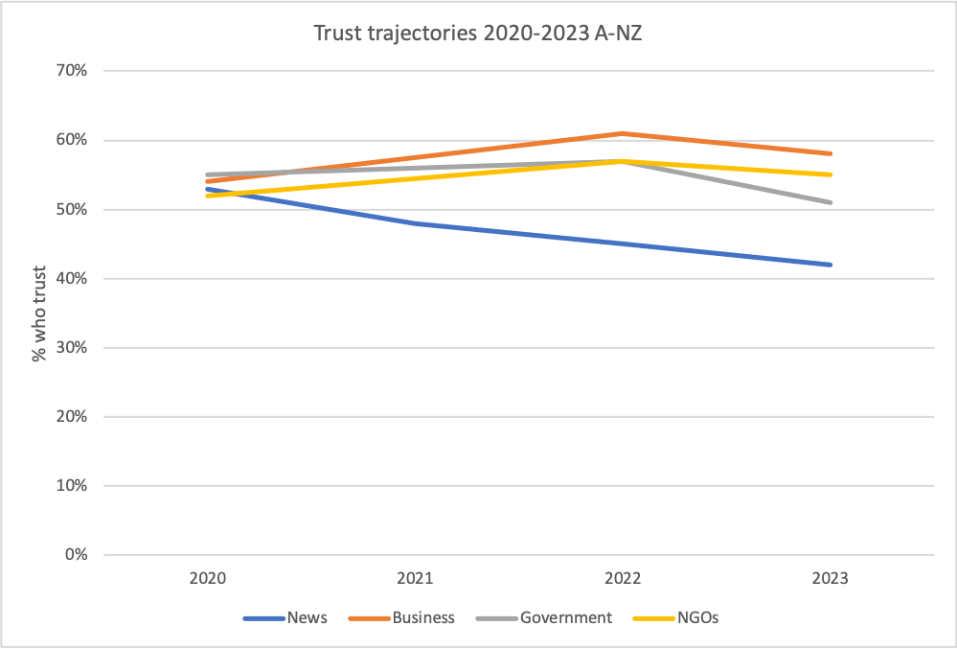
Figure 3. Trust trajectories 2020-2023 in Aotearoa New Zealand Sources: JMAD, Acumen Edelman Trust Barometer New Zealand; note: 2021 data only available for news

Global trust comparisons
Globally, trust in news grew slightly by 2pp to 40% from 2020 to 2024, the result of a significant gain of 6pp in 2021 and then two consecutive falls before it stabilised. (Table 2). Trust in media in general, however, tumbled globally, down 11pp to 50%, though it too stabilised in 2024. Trust in business fell 7pp to 63%, while trust in government fell 8pp to 51%. Both these falls were in opposition to the small rise made by news. Globally, trust in NGOs fell 11pp to 59%.

These global trends differ to their counterparts in Aotearoa New Zealand. In statistical terms, trust in media (generally), business, government and NGOs all followed similar trajectories globally to each other, with 2021 clearly a year that changed their directions. All four were declining until in 2021 their paths levelled off considerably, with trust in NGOs and business even starting to rise again. Trust in news globally, however, appears to have travelled an mirror-image route, growing until 2021 when it started to fall (see Fig. 4). While all three other trust relationships saw their decline halted in 2021, and then even slightly improved in 2022 in some cases, trust in news was growing globally until 2021 when it started to decline again.

Table 2. Trust in media, news and social institutions (global)
 | 2020 | 2021 | 2022 | 2023 | 2024 | Change 2020-23
Overall trust in news | 38% | 44% | 42% | 40% | 40% | +2
Trust in media | 61% | 51% | 50% | 50% | 50% | -11
Trust in business | 70% | 61% | 61% | 62% | 63% | -7
Trust in government | 59% | 53% | 52% | 50% | 51% | -8
Trust in NGOs | 70% | 57% | 59% | 59% | 59% | -11
Sources: Edelman Barometer, Reuters Institute for Study of Journalism

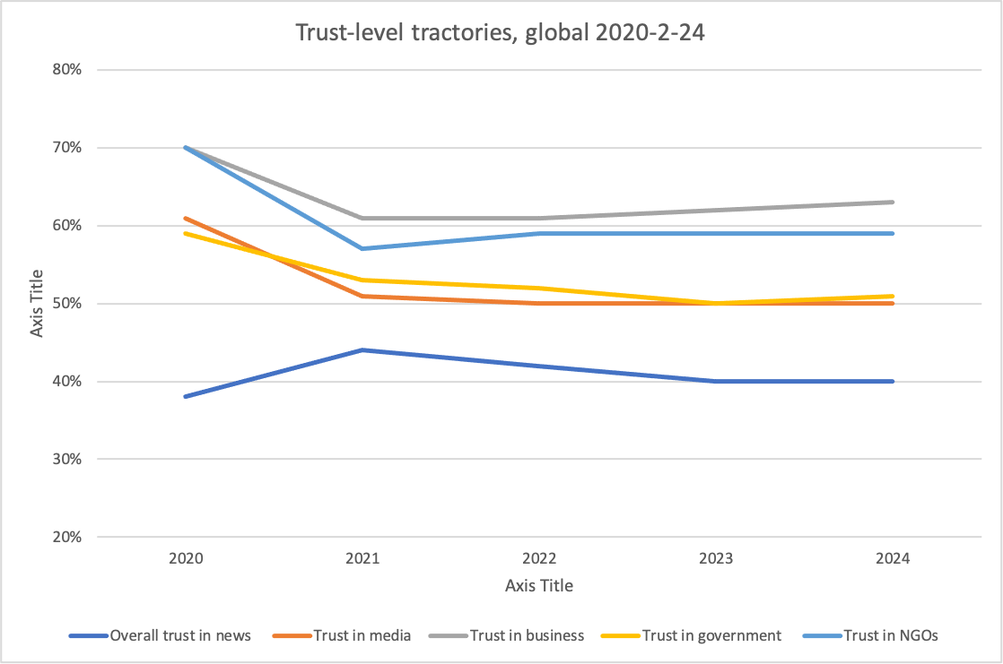
Figure 4. Trust trajectories globally in 2020-2023. Sources: Edelman Barometer, Reuters Institute for Study of Journalism

Table 3. Trust comparison NZ & global 2022/2023
 | A-NZ | Global
News | 42% | 40%
Business | 58% | 62%
Government | 51% | 50%
NGOs | 55% | 59%
Sources: Edelman Barometer, Reuters Institute, JMAD, Dynata
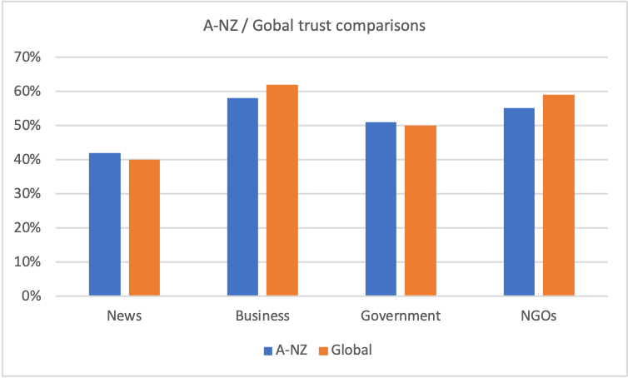
Fig 5. Trust comparisons between Aotearoa New Zealand and global averages. Sources: Edelman Barometer, Reuters Institute, JMAD, Dynata

Trust in news and trust in government
Our subordinate research question asked to what extent trust in news was directly linked to trust in politics and government. A perceived conspiracy of some sort between the political elite and the news media was a reason given by 49% of respondents who did not trust news in 2023, a figure that dropped to 43% in 2024 (Myllylahti & Treadwell, 2024, p. 27). But trust in government in Aotearoa New Zealand (50%) is not nearly as low as trust in news (33%). While still relatively high, trust in government dropped 6pp in 2023 and 4pp over the four-year period, according to the Acumen Edelman Trust Barometer New Zealand. “While in line with the global average, New Zealand has historically bucked the trend with higher levels in trust in Government” (2023). Trust in Government leaders has declined by 5pp, however, moving from the trust barometer’s “neutral” category to its one of “distrust”. Fewer than half of New Zealanders trust Parliament (47%), though that is 8pp higher than the average across OECD countries (OECD, n.d.). See Figure 6. In 2021, 55% of the population trusted the public service (Gallup World Poll, 2021).

Meanwhile, according to the OECD, almost half of New Zealanders (47%) trust Parliament, 8pp higher than the average across OECD countries. Across OECD countries, parliaments and political parties are the least trusted public institutions. In terms of trust in Parliament, New Zealand fares comparatively well, behind only Norway, Finland, Denmark and Ireland (Fig. 6).
In our focus groups of people who mistrust the news, we wanted to see, among other things, if connections between trust in news and trust in government might emerge, helping clarify issues that led to our subordinate research question. In Focus Group 1 (FG1), with members aged 18-34, the news media was seen to have more than political allegiance to the government of the day. One male participant (MP) said he mistrusted the news media because “took heaps of money from the Government, and they just totally went with the Government narrative. There was no dissent, like the whole mainstream media was all on board.” He was referring to payments to the media from the Labour Government’s Public Interest Journalism Fund, which helped create such perceptions. In FG2, aged 55-64, however, group members agreed there were institutions they mistrusted, some to very high levels of mistrust, but the Government was not generally agreed to be one. Rather, the institutions participants mistrusted institutions were almost exclusively because of personal disputes they had had with them. A FP, who lived through the Christchurch earthquake of 2011, had “a deep mistrust of insurance companies”. Another FP, who received state support after an injury, said she did not trust any agency, but particularly the Accident Compensation Corporation. Another FP had a daughter who lived with Downs Syndrome and she didn’t trust any of the five agencies she had to deal with. A MP had seen his own children failed by the education system, which he could no longer trust. Another MP did not trust universities, which he said had been taken over by social Marxists. A FP, who moved to New Zealand two decades earlier, had no respect for banks. None of these participants particularly mistrusted government as an institution, though several expressed negative views of political parties. We found no direct link between respondents’ mistrust of news and their mistrust of other social institutions.

Figure 6. Trust in Parliament in Aotearoa New Zealand and internationally. Source: NZ Parliament and OECD

The New Zealand Parliament’s own reporting of public trust, which enjoyed a peak of 61% in 2020 as Aotearoa New Zealand endured the onset of Covid-19, reverted to pre-pandemic levels in 2022 (Fig. 7).
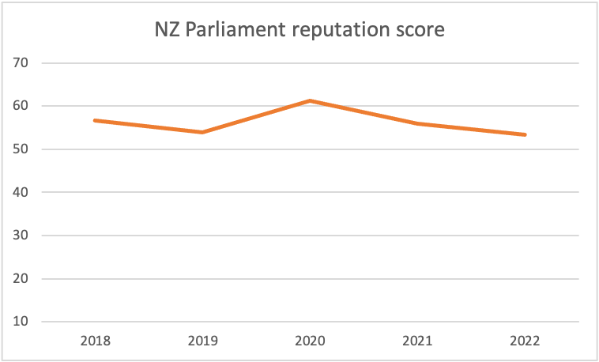
Figure 7. NZ Parliament reputation score (possible score: 10-100) Source: New Zealand Parliament/Kantar

Conclusions
To answer the research questions we set ourselves, we compared data about trust in news with data sets about trust in other social institutions. While these were gathered in research initiatives that varied in nature and contexts, including our own, the trajectories of change in levels of trust could nevertheless be discerned overall. From 2020, trust in news in Aotearoa was falling while trust in the other three was rising. When trust in government fell in 2022, so did trust in business and NGOs, yet trust in news seemed unaffected, continuing its own steady trajectory downward. Such were the differences in trust trajectories, we were confidently able to eliminate correlations between trust in news and trust in government, business and NGOs.

Aotearoa New Zealand
The trajectories of trust in government, business and NGOs in Aotearoa New Zealand (2020-2023) all rose and then fell from a 2022 peak, while trust in news fell away rapidly on its own on a seemingly unrelated trajectory. Being able to eliminate direct connections to the trajectories of other trust relationships suggests more direct and specific influences might have shaped the path of news trust. Perhaps trust in news as an institution has also felt the forces of growing wider social distrust but other, apparently stronger, influences have set it on its own downward direction. Whether this disconnect between trust in news and trust in other social institutions is encouraging is perhaps a matter of perspective, and whether news trust can be rebuilt in today’s transformed media world a matter of conjecture. Can strengthening the visibility of factuality and solution-seeking as fundamental values of journalism practice (re)identify journalism as distinct and reliable? If growing levels opinion in news are alienating citizens, do we need to find ways to get back to restore a democratic distance between the ideas of reportage and influencing? Whatever the approach, understanding that trust in news is in its own lane, and not tethered directly to trust in institutions, helps clarify the research site, whatever the possibilities of redemption. And if issues bespoke to journalism do emerge, then bespoke solutions might indeed be conceived.

Global trends
Internationally, in directional terms, the inverse was true, with trust in media, government, business and NGOs falling sharply before levelling off over the period analysed (2020-2024), and business and NGOs even recovering a little (Fig. 4). News took a mirror-image course, rising strongly in 2021 before heading downhill again and continuing to do so to 2024. As trust in news rose, trust in other institutions fell. From 2021, trust in news fell as trust in the others rose again. A relationship between these obverse trends cannot be immediately eliminated. Robust public-interest journalism may well lifts its own reputation while commensurately impacting those of other institutions negatively. What can be eliminated is the idea that journalism is simply another self-serving and untrustworthy institution in a modern world where all social institutions are self-interested and untrustworthy. The implication of a general decline in trust across all social institutions might speak to dangerous fissures in the wider social contract that journalism has been unable to extricate itself from, going down with the ship, so to speak. However, journalism’s levels of trust are clearly not falling or rising in concert with those of other institutions. We take from this a possibility to examine journalism’s trust issues in fine detail with a sense of purpose, knowing they are related to wider social issues, as the literature would suggest, but that they are also specific to its fourth-estate role and the relationship it has with a unique audience, the democratic public.
Globally, publics want news to be “accurate, fair, avoid sensationalism, be open about any agendas and biases including lack of diversity, own up to mistakes – and not pull punches when investigating the rich and powerful” (Newman et al., 2024, p. 25). If news is in its own lifeboat, not tethered to a listing mothership of social-institutional mistrust, it has a chance to address trust issues on its own terms, and then grow public understanding of wider social crises, the only way in a democracy such issues can be addressed.

Limitations and research opportunities
Comparing publicly available data sets about trust brings with it clear limitations. Differing research agendas, frameworks and instruments will influence research outcomes in differing ways. Nevertheless, this study took an overarching view of local and global trust levels in news, government, business and NGOs, and found there were indeed meaningful patterns – in both similarities and contrasts – when these data sets were compared. A bird’s-eye view, in fact, allowed us to see them.

Our two focus groups were held online to encourage a range of respondents from across the country, particularly for the younger group for which we had been warned it might be difficult to enroll members. It proved so, and in the end only four people made up the younger group. Focus groups are generally thought to reach research validity with six members and we acknowledge the limitations brought by the low number. However, given both the difficulty of enrolling younger respondents in such research and the productive discussion that did take place, an analysis is offered here, within the circumscriptions of those parameters and with a caveat on direct findings. For the older group, 10 confirmed they would take part and eight formed the focus group on the night.

As noted above, research opportunities emerging from these findings might be shaped by research contexts and frameworks. But from our perspective, it encourages further research on journalism-specific trust issues. These might be small steps, but to start off with a clearer picture of connections and disconnections within the trust puzzle will help.

References
Acumen Edelman Trust Barometer NZ (2023), ‘The Acumen Edelman Trust Barometer’, available at: https://acumennz.com/the-acumen-edelman-trust-barometer/2023/ (accessed 10 September 2024).
Andersen, K., Shehata, A. and Andersson, D. (2023), ‘Alternative news orientation and trust in mainstream media: A longitudinal audience perspective’, Digital Journalism, vol. 11, no. 5, pp. 833–852, available at: https://doi.org/10.1080/21670811.2021.1986412 (accessed 1 August 2024).
Arguedas, A.R., Banerjee, S., Mont’Alverne, C., Toff, B., Fletcher, R. and Nielsen, R.K. (2023), ‘News for the powerful and privileged: How misrepresentation and underrepresentation of disadvantaged communities undermines their trust in news’, Reuters Institute for the Study of Journalism, available at: https://reutersinstitute.politics.ox.ac.uk/news-powerful-and-privileged-how-misrepresentation-and-underrepresentation-disadvantaged (accessed 18 November 2025).
Banerjee, S., Mont’Alverne, C., Arguedas, A., Toff, B., Fletcher, R. and Nielsen, R.K. (2023), ‘Strategies for building trust in news: What the public say they want across four countries’, Reuters Institute for the Study of Journalism, available at: https://reutersinstitute.politics.ox.ac.uk/sites/default/files/2023-09/Banerjee_et_al_Strategies_for_Building_Trust_in_News.pdf (accessed 7 July 2024).
Brady, H. and Kent, T. (2022), ‘Fifty years of declining confidence and increasing polarization in trust in American institutions’, Daedalus, vol. 151, no. 4, pp. 43–66 (accessed 22 January 2025).
Brüggemann, M., Engesser, S., Büchel, F. and Castro, L. (2014), ‘Hallin and Mancini revisited: Types of Western media systems’, Journal of Communication, vol. 64, pp. 1037–1068, available at: https://doi.org/10.1111/jcom.12127 (accessed 1 July 2024).
Engelke, K., Hasse, V. and Winnterlin, F. (2019), ‘On measuring trust and distrust in journalism: Reflection of the status quo and suggestions for the road ahead’, Journal of Trust Research, vol. 9, no. 1, available at: https://doi.org/10.1080/21515581.2019.1588741 (accessed 17 October 2024).
Fink, K. (2019), ‘The biggest challenge facing journalism: A lack of trust’, Journalism, vol. 20, no. 1, pp. 40–43.
Fisher, C. (2016), ‘The trouble with “trust” in news media’, Communication Research and Practice, vol. 2, no. 4, pp. 451–456, available at: https://doi.org/10.1080/22041451.2016.1261251 (accessed 17 October 2024).
General Elimination Methodology (n.d.), ‘Overview’, available at: https://s33320.pcdn.co/wp-content/uploads/General-Elimination-theory-briefing_Secured.pdf (accessed 17 July 2024).
Gluckman, P., Bardsley, A., Spoonley, P., Royal, C., Simon-Kumar, N. and Chen, A. (2021), ‘Sustaining Aotearoa New Zealand as a cohesive society’, Koi Tū: The Centre for Informed Futures, available at: https://informedfutures.org/social-cohesion/ (accessed 23 October 2024).
Hanitzsch, T., Van Dalen, A. and Steindl, N. (2018), ‘Caught in the nexus: A comparative and longitudinal analysis of public trust in press’, The International Journal of Press/Politics, vol. 23, no. 1, pp. 3–23.
Hanitzsch, T., Hanusch, F., Ramaprasad, J. and de Beer, A. (eds.) (2019), Worlds of Journalism: Journalistic Cultures Around the Globe, Columbia University Press.
Hameleers, M., Brosius, A. and de Vreese, C.H. (2022), ‘Whom to trust? Media exposure patterns of citizens with perceptions of misinformation and disinformation related to the news media’, European Journal of Communication, vol. 37, no. 3, available at: https://doi.org/10.1177/02673231211072667.
Hobbes, T. (2008), Leviathan (J.C.A. Gaskin, ed.), Oxford University Press.
Kantar (2023), ‘Survey of the New Zealand public’, available at: www.parliament.nz/media/10229/office-of-the-clerk-survey-of-the-new-zealand-public-january-2023-report.pdf (accessed 17 July 2024).
Kalogeropoulos, A., Suiter, J., Udris, L. and Eisenegger, M. (2019), ‘News media trust and news consumption: Factors related to trust in news in 35 countries’, International Journal of Communication, vol. 13, pp. 3672–3693, available at: https://ijoc.org/index.php/ijoc/article/view/10141.
Keane, J. (2011), ‘Monitory democracy?’, in Alonso, S., Keane, J. and Merkel, W. (eds.), The Future of Representative Democracy, Cambridge University Press, pp. 212–235.
Moran, R. and Nechushtai, E. (2023), ‘Before reception: Trust in news as infrastructure’, Journalism, vol. 24, no. 3, pp. 457–688.
Lewis, S.C. (2018), ‘Lack of trust in the news media, institutional weakness, and relational journalism as a potential way forward’, Journalism, vol. 20, no. 1, pp. 44–47.
Myllylahti, M. and Treadwell, G. (2020–2024), ‘Trust in news in Aotearoa New Zealand’, Centre for Journalism, Media and Democracy, available at: www.jmadresearch.com/trust-in-news-in-new-zealand.
Myllylahti, M. and Treadwell, G. (2024), ‘Trust in news in Aotearoa New Zealand’, Centre for Journalism, Media and Democracy, available at: www.jmadresearch.com/trust-in-news-in-new-zealand.
Myllylahti, M. and Treadwell, G. (2025), ‘Trust in news in Aotearoa New Zealand’, Centre for Journalism, Media and Democracy, available at: www.jmadresearch.com/trust-in-news-in-new-zealand.
Myllylahti, M. and Treadwell, G. (2022), ‘In media we trust? A comparative analysis of news trust in New Zealand and other Western media markets’, Kōtuitui: New Zealand Journal of Social Sciences Online, vol. 17, no. 1, pp. 90–100, available at: https://doi.org/10.1080/1177083X.2021.1948873.
Myllylahti, M. (forthcoming), ‘New Zealand media landscape’, in Schapals, A.K. and Pentzold, C. (eds.), Media Compass: A Companion to International Media Landscapes, Wiley.
Newman, N. and Fletcher, R. (2017), ‘Bias, bullshit and lies: Audience perspective on low trust in the media’, Reuters Institute for the Study of Journalism, available at: https://reutersinstitute.politics.ox.ac.uk/our-research/bias-bullshit-and-lies-audience-perspectives-low-trust-media.
Newman, N., Fletcher, R., Kalogeropoulos, A. and Nielsen, R.K. (2019), ‘Reuters digital news report 2019’, Reuters Institute for the Study of Journalism, available at: https://reutersinstitute.politics.ox.ac.uk/our-research/digital-news-report-2019.
Newman, N., Fletcher, R., Eddy, K., Robertson, C. and Nielsen, R.K. (2023), ‘Reuters digital news report 2023’, Reuters Institute for the Study of Journalism, available at: https://reutersinstitute.politics.ox.ac.uk/sites/default/files/2023-06/Digital_News_Report_2023.pdf.
Newman, N., Fletcher, R., Robertson, C. T., Arguedas, A. & Nielsen. R.K. (2024). ‘Reuters digital news report 2024’, Reuters Institute for the Study of Journalism, available at: https://reutersinstitute.politics.ox.ac.uk/digital-news-report/2024
OECD (n.d.), ‘Drivers of public trust in institutions in New Zealand’, OECD, available at: www.oecd-ilibrary.org/sites/977ea96f-en/index.html?itemId=/content/component/977ea96f-en.
Pickard, V. (2021), ‘A new social contract for platforms’, in Moore, M. and Tambini, D. (eds.), Regulating Big Tech: Policy Responses to Digital Dominance, Oxford University Press, pp. 323–338.
Prochazka, F. and Schweiger, W. (2019), ‘How to measure generalized trust in news media: Adaptation and test of scales’, Communication Methods and Measures, vol. 13, no. 1, pp. 26–42.
Sjøvaag, H. (2018), ‘Journalism’s social contract’, Oxford Research Encyclopedia for Communication, available at: https://doi.org/10.1093/acrefore/9780190228613.013.828.
Sjøvaag, H. (2010), ‘The reciprocity of journalism’s social contract’, Journalism Studies, vol. 11, no. 6, pp. 874–888, available at: https://doi.org/10.1080/14616701003644044.
Strömbäck, J., Tsfati, Y., Boomgaarden, H., Damstra, A., Lindgren, L., Vliegenthart, R. and Lindholm, T. (2020), ‘News media trust and its impact on media use: Toward a framework for future research’, Annals of the International Communication Association, vol. 44, no. 2, pp. 139–156, available at: https://doi.org/10.1080/23808985.2020.1755338.
Toff, B., Badrinathan, S., Mont’Alverne, C., Ross Arguedas, A., Fletcher, R. and Nielsen, R.K. (2021), ‘Depth and breadth: How news organisations navigate trade-offs around building trust in news’, Reuters Institute for the Study of Journalism, available at: https://reutersinstitute.politics.ox.ac.uk/depth-and-breadth-how-news-organisations-navigate-trade-offs-around-building-trust-news.
Treadwell, G. (2023), ‘Print and online’, in Hope, W. (ed.), The Aotearoa New Zealand Media Ownership Report, Centre for Journalism, Media and Democracy, pp. 50–66, available at: https://www.jmadresearch.com/new-zealand-media-ownership.
Usher, N. (2018), ‘Rethinking trust in the news: A material approach through “objects of journalism”’, Journalism Studies, vol. 19, no. 4, pp. 564–578, available at: https://doi.org/10.1080/1461670X.2017.1375391.
Van den Bos, K. (2023), ‘Trust in social institutions: The role of informational and personal uncertainty’, in Forgas, J.P. et al. (eds.), The Psychology of Insecurity: Seeking Certainty Where None Can Be Found, Taylor and Francis Group, pp. 288–289.
Verboord, M., Janssen, S. and Marquart, F. (2023), ‘Institutional trust and media use in times of cultural backlash: A cross-national study in nine European countries’, The International Journal of Press/Politics, available at: https://doi.org/10.1177/194016122311875.
Zelizer, B. (2012), ‘On the shelf life of democracy in journalism scholarship’, Journalism, vol. 14, no. 4, pp. 459–473.

