Expert Eyes, Machine Hands: Creativity, Aesthetics, and Accountability in GenAI
Generative artificial intelligence (GenAI) has become one of the defining cultural technologies of the 2020s, transforming not only how content is produced but also how creativity itself is imagined. From text generation to image synthesis, GenAI blurs distinctions between professional and amateur practice, art and automation, originality and imitation. These shifts reach far beyond the studio or agency: they unsettle cultural hierarchies, redistribute expertise, and reconfigure what it means to author or evaluate creative work with scholars and practitioners highlighting both GenAI’s disruptive and enabling potential (Amankwah-Amoah et al.; Coffin; Hartmann et al.; Matthews et al). As such, GenAI sits squarely at the intersection of technology and culture, making it vital to examine how creative practitioners experience and negotiate its affordances. These questions mirror broader cultural discussions about automation, expertise, aesthetics and creativity in digital media, situating our research within contemporary debates about creativity in an algorithmic age.
This article explores those negotiations through a collaborative autoethnography (Chang) in which creative professionals who are also educators worked with GenAI tools to develop an advertising campaign from concept to final artefact. By grounding our analysis in lived experience, we examine not only what GenAI can produce, but how it alters the creative process. Drawing on Csikszentmihalyi’s systems model of creativity (697) and Bourdieu’s account of cultural capital (3), we situate our reflections within a wider theoretical conversation about expertise, taste, and technological mediation. These frameworks allow us to interrogate how GenAI participation affects the balance between human judgement and machine generation or between creative flow and algorithmic patterning. In doing so, we contribute to broader debates on the cultural implications of GenAI by identifying how expert practitioners sustain, redefine, and sometimes resist aesthetic standards in an era of algorithmic co-creation.
The Positive Case for GenAI in Creative Practice
The rapid rise of GenAI has intensified debates about its role in creative practice, particularly in creative industries where efficiency, cost-saving, and innovation are central (Cui et al.; Hartmann et al.; Matthews et al.). The issue is no longer simply whether GenAI is useful but how it reshapes the very conditions of creativity. By automating routine tasks, the technology frees practitioners to focus on more imaginative and rewarding work. As Amankwah-Amoah et al. highlight, GenAI’s transformative potential can produce “compelling” content without the burden of extensive “manual research and editing” (2), saving creative professionals time and energy that can be repurposed to more invigorating and empowering activities. Yet, as Csikszentmihalyi’s model suggests, creativity emerges from the dynamic interaction between domain (cultural knowledge), field (gatekeepers and experts), and individual (the creator) (697). When GenAI intervenes in this system, it can rebalance these forces, enabling rapid idea generation but also introducing “stylistic biases” (Atkinson and Baker, 1065) that affect the domain of possible outcomes, or expectations that one can demand more for less (Nairn et al., 138). This theoretical perspective stresses that what feels like creative freedom can also be a reconfiguration of control.
In the debates supporting GenAI, Hettrich et al. suggest that the technology can challenge human creators to think beyond the obvious by offering alternative directions that spark the creative imagination in ways they might not reach alone. Its adoption, then, is not merely a matter of convenience but a means of expanding creative possibility. What debates advocating for GenAI use emphasise is the fact that its use does not sideline the human creator. Instead, GenAI reshapes their role: Osadchaya et al. underline its function as collaborator and catalyst, enabling creatives to overcome the ‘tyranny of the blank page’ (574) while Cui et al. highlight how it sparks novel ideas and accelerates responses to creative briefs (170). These perspectives make clear that GenAI should not be viewed as a competitor to human creativity but as a partner that expands its possibilities, challenging practitioners to reimagine both the process and the product of creative work. From a systems perspective, these collaborations demonstrate how GenAI alters what Csikszentmihalyi describes as a flow state: the absorption and momentum characteristic of deep creative engagement by accelerating iteration cycles and reframing what counts as exploration (697).
Furthermore, audiences are also becoming less apprehensive about AI-generated content, with some studies showing they find AI images equally persuasive, especially in areas such as advertising and brand communication (Hartmann et al.). This suggests that combining GenAI with human expertise can enhance both the creative potential of the work and its acceptance by audiences.

The Negative Case for GenAI in Creative Practice
Despite GenAI’s growing value in creative processes, anxieties remain that it could displace professionals and dilute the aesthetic and quality standards traditionally associated with creative work that is exclusively human-made (Amankwah-Amoah et al.; Coffin). Scholars such as Runco contend that GenAI produces only “pseudo-creativity” (1), outputs that may appear effective but lack the contextual grounding and cultural depth of human innovation. Creative professionals echo this scepticism, observing that while AI can generate polished drafts, the raw outputs often feel “off” (Matthews et al., 15) or are “formulaic” outputs that undermine the intrinsic drive for experimentation and play that defines creative practice (Runco, 1). These critiques highlight a deeper concern that, as GenAI becomes more widely adopted, the benchmarks by which creativity is judged may be lowered or distorted. Furthermore, from a Bourdieusian lens, the tension between technology and expertise reflects a struggle over cultural capital and taste: if expertise is what legitimises creativity, then the automation of creative labour threatens to redistribute symbolic power toward technological systems.
The democratisation of generative tools, then, adds another layer of complexity. With platforms like DALL·E and Midjourney enabling anyone to produce seemingly professional content, the boundaries of what counts as valuable creativity risk becoming blurred (Ahmed and Ali; Chamakiotis and Panteli; Matthews et al). Studies point to both the promise and the peril of this accessibility. Namely, GenAI lowers barriers to participation, but in doing so, it may also flood cultural spaces with superficial, poorly developed, distorted work (Ahmed and Ali), referred to openly as “AI slop” (Smith and Southerton, 2). The degradation of creative content could be inevitable because, as Chamakiotis and Panteli argue, GenAI privileges speed and quantity over originality and finesse. In professional settings, this tension becomes evident as GenAI enables less experienced practitioners to produce more polished work (Hettrich et al., 798), but excessive dependence on the technology may hinder the growth of critical thinking and the refinement of creative skills. Taken together, these dynamics raise important questions about how to preserve aesthetic standards and creative depth in an era where content creation is increasingly democratised.
Accordingly, expertise remains crucial. Creativity has long been judged not only by novelty but also by peer recognition, audience reception, or what Csikszentmihalyi refers to as gatekeepers (696). Experts are well-placed to uphold aesthetic and quality standards because they understand the rules and practices that govern their discipline. As Bourdieu argued, those with cultural competence are deemed the most versed in encoding value in creative work and by extension maintain “explicit or implicit schemes of perception and appreciation” (2). Previous studies highlight this point, showing that while professionals view GenAI as helpful for generating ideas or producing early drafts, they stress that only a specialist can refine those outputs into work that is truly original and meaningful (DiStefano et al.; Matthews et al.). In this sense, the value of expertise lies not in resisting technology but in knowing how to use it effectively, drawing out its benefits while guarding against formulaic or tone-deaf outcomes, especially given the copyright infringement concerns that accompany GenAI-produced work.
As scholars have contended, copyright conflict in creative industries stems from GenAI models using vast amounts of protected works as training data without permission (Lucchi; Torrance and Tomlinson). Supporters claim this ‘fair training’ is transformative, non-expressive, and socially beneficial (Lucchi; Torrance and Tomlinson), while critics see it as misappropriation that enables derivative, market-harming outputs (Lucchi; Torrance and Tomlinson). Given the loose legal restrictions that currently exist, it falls, in part, to creative experts to operate GenAI technology cautiously to prevent the misuse and exploitation of the creative work of others.

Approaching the Research
Our research set out to investigate how we, as experts in visual communication, experience GenAI. We are not only creative professionals with years of experience in our respective industries, but also academics responsible for teaching undergraduates the skills required for effective visual communication, positioning us as both practitioners and gatekeepers of disciplinary standards. As part of our research, we aimed to understand not only the functional opportunities and challenges presented by these technologies, but also the evaluative judgments that can be made about AI-generated content.
We operationalised this inquiry through a collaborative autoethnography (Chang) anchored to a shared industry-style task. Using a single creative brief for a new energy drink launch (the new energy drink was presented as the first on the market to use ingredients sourced from the Amazon), we asked each practitioner–researcher to develop an end-to-end brand identity using GenAI tools (namely those offered by OpenAI particularly DALL·E and ChatGPT-5) as the primary means of production—covering naming, logo, optional mascot, can packaging, a bus-shelter poster, and (optionally) a 15–20s spot. The brief served both as the task environment and as the evaluation frame against which creative adequacy was judged.
Participants (MG, JM, AA, DF, AD) worked independently while “thinking aloud,” screen-recording their sessions, and retaining prompt logs, intermediate iterations, and exported artefacts; AN oversaw the process and methodological consistency. Our protocol was AI-first: participants attempted to complete all deliverables with GenAI; where they departed from this (e.g., corrective manual refinements), those moments were explicitly noted and treated as analytical data about breakdowns and boundary conditions. We then convened an artefact-led group focus group to review outputs against the brief, surface pain points, and identify what worked and what did not from the vantage point of expert practice and pedagogy.
Analytically, we conducted a reflexive thematic analysis (Braun and Clarke) across three data streams—process recordings and transcripts, prompt/iteration logs, and the group discussion—linking lived experience to evaluative judgements about creativity and quality. Accordingly, operating from an experiential perspective, we were able to inductively examine both the functional affordances (speed, exploration, iteration) and frictions (fidelity loss, aesthetic convergence, control over detail) of GenAI, and to clarify how expert judgement mediates whether machine-assisted work meets, falls short of, or redefines professional standards. Drawing on Csikszentmihalyi’s model, we viewed each participant’s engagement with AI as an interaction between personal expertise (individual), the creative brief and aesthetic conventions (domain), and peer evaluation within our group (field). This structure helped ensure our analysis remained theoretically grounded, linking micro-level reflections to broader cultural questions of authorship, taste, and accountability.

Inspired Ideation
Our experiences of working with GenAI revealed just how valuable the technology was for brainstorming and exploration. We consistently reflected on how the act of engaging with ChatGPT-5 helped us move from a myriad of options and creative blocks into creative momentum, often describing the experience as both liberating and stimulating. One recurring idea was the way the GenAI enabled them to overcome the inertia of starting out. For instance, AA noted that she was able to become “unstuck” by having a GenAI partner to “bounce ideas off”, a sentiment echoed by others who felt the GenAI created an immediate entry point into the creative process.
Another shared dimension of experience was the sense of efficiency in narrowing options. AD explained how the GenAI allowed him to test and discard unworkable directions early, giving him confidence to focus on ideas with more potential. DF described a similar advantage, pointing to the “quick iteration” made possible by GenAI and how it could generate multiple text-based possibilities, such as brand names, slogans, or directions.
The experience of brainstorming with GenAI was also described as sparking ideas that participants claimed they would not have reached independently. JM, for example, highlighted how a loose brief could be transformed into “high-fidelity renders” that pushed him into new design spaces and kept inspiration flowing. MG similarly explained how the GenAI’s capacity to rapidly canvas and condense research from Amazonian animals to Portuguese vocabulary did not just save him time but opened imaginative avenues that he could then refine into his own creative vision. In these ways, the technology served less as a substitute for human creativity and more as a catalyst, nudging us toward unanticipated directions.
Our accounts align closely with scholarship suggesting that GenAI enhances not just efficiency but also imagination by encouraging creators to think beyond conventional pathways (Cui, et al.; Hartmann, et al.; Hettrich, et al., Matthews, et al). Within Csikszentmihalyi’s terms, GenAI acted as an externalised flow facilitator: it sustained momentum, expanded associative links, and provided immediate feedback loops that simulated collaborative ideation. In this sense, our experiences demonstrate that brainstorming with AI is not merely a functional shortcut but a creative encounter in its own right, one that reshapes how ideas emerge and evolve.

Familiarity with the tools
A second moment of experience that emerged strongly from the reflections concerned the sense that OpenAI tools carried a “memory” of its users and often defaulted to preconceived understandings of our styles and domains. We described this as a double-edged sword. On one hand, the technology’s ability to learn our tendencies meant interactions could feel more tailored and efficient. Yet, on the other hand, this personalisation sometimes narrowed the scope of exploration, creating outputs that were less surprising or more rigid than had been hoped. What became clear in these reflections was a tension between the promise of open-ended brainstorming and the reality of a GenAI that appeared to anchor itself in prior patterns of interaction.
Several of us explicitly noted how past usage influenced what the GenAI produced. MG explained that over time, his ChatGPT “had learned to work with” him, and because he primarily relied on it for data science tasks, “it knows that I work with academic rigour. It knows that I work with code, so every now and then it would actually spit out Python code at me.” AD echoed this experience, reflecting that since so many of his past prompts had begun with “give me code for,” the GenAI seemed to perceive their relationship as “more analytical, and it’s more, you know, here’s a specific task we’re solving, not so much here’s something we’re exploring.” For him, this meant that had the brief been to create a Python module, “we would have had a better time of it, because we know exactly where the caveats are.” Both accounts underline how the GenAI’s learned behaviour risked funnelling creative processes back into familiar domains.
Others in the team extended this idea by considering how memory shaped their overall creative encounters. JM remarked that “it does build that kind of memory for people that have used it,” noting that when “memories [are] turned on, this will colour” the responses. He felt his own lack of frustration with the project stemmed from his long-standing “methodology” of working with the system, which gave him an awareness of its limits and common pathways. DF similarly recalled a moment when the GenAI pulled in “data from a whole other chat” after he began a new conversation and asked about the project, a misapplication that nevertheless highlighted the model’s tendency to overreach by leaning on remembered context.
We also spoke about how our strategies for interacting with the GenAI were shaped by these experiences. AD admitted that he sometimes withheld the full brief because “when it has the context, it just jumps the gun,” an approach he recognised as “coloured by other experiences he had with it.” AA likewise wondered if the GenAI had “taken that on board” that she used it mainly for “ideation and refinement.” She found it reliable for brainstorming but observed that it seemed less effective when asked to generate images, almost as though it had learned her preferred use and resisted branching into other tasks.
Together, these reflections highlight the ambivalence of experiencing a GenAI that appears to remember and anticipate. While this familiarity seemed to increase efficiency, it also narrowed exploration: a process Bourdieu might describe as the reproduction of habitus within a digital system (6). The GenAI model effectively learned and reinforced each participant’s preferences, which could reduce the novelty of output. This interaction exemplifies how algorithmic personalisation, though convenient, can, and in some instances did, amplify pre-existing creative dispositions rather than challenge them.

Aesthetic likes and preferences
A further dimension of experience participants reflected on was the aesthetics produced through their engagement with the GenAI tools. Here, the conversation often oscillated between moments of excitement when the GenAI generated something visually striking and frustration when the results felt generic, inconsistent, or resistant to refinement. What was clear across our experiences was that aesthetics mattered deeply to the creative process, and the GenAI’s ability—or inability—to deliver on those expectations shaped how useful we ultimately found it.
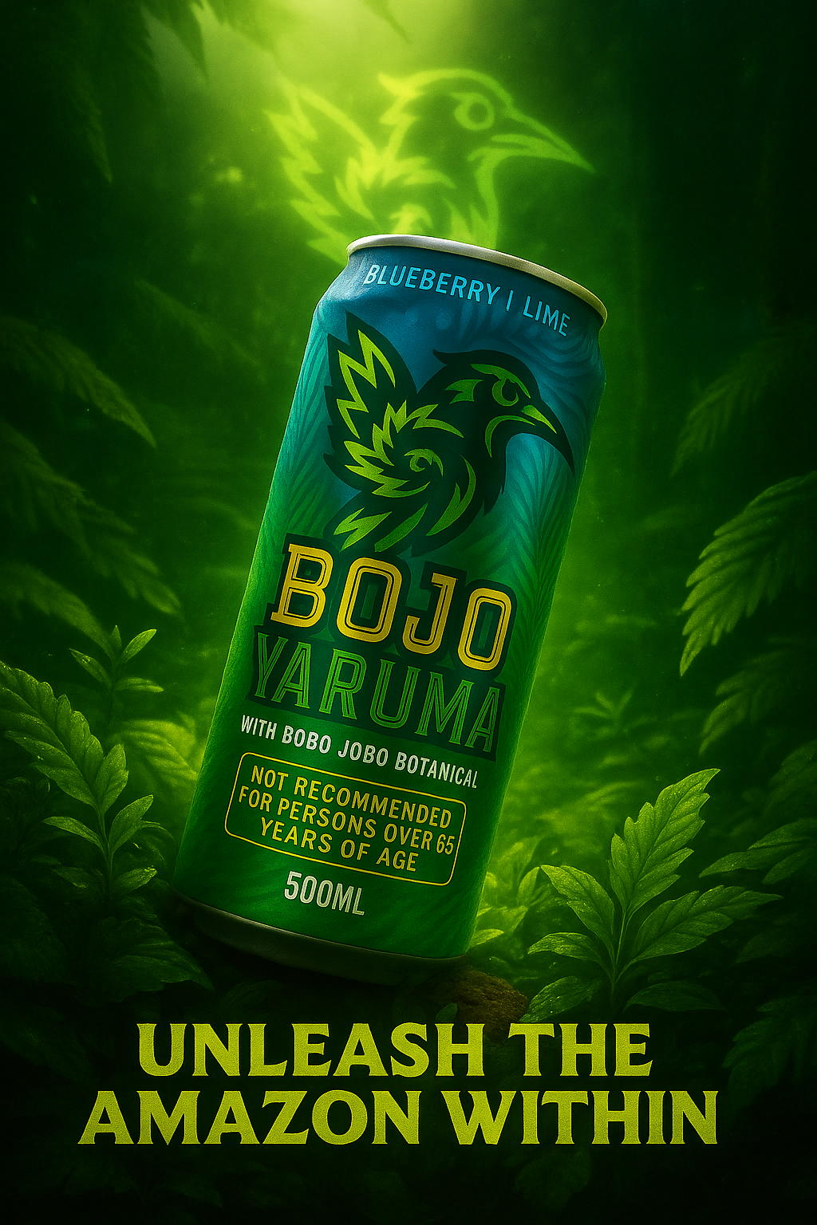
Figure 1: Bojo Yaruma final bus stop poster advertisement
On the positive side, some of us frequently described the thrill of seeing loose ideas turned into polished visuals. JM emphasised how rewarding it was to go from “a loose brief” to “fully developed concepts” (see Figure 1), and the way the GenAI could quickly provide “thumbnails of treatments” that opened up design pathways. Similarly, AD praised certain outputs, noting that the GenAI’s renderings were “more solid than a sketch” he could have produced himself, which made it easier to communicate a general direction.
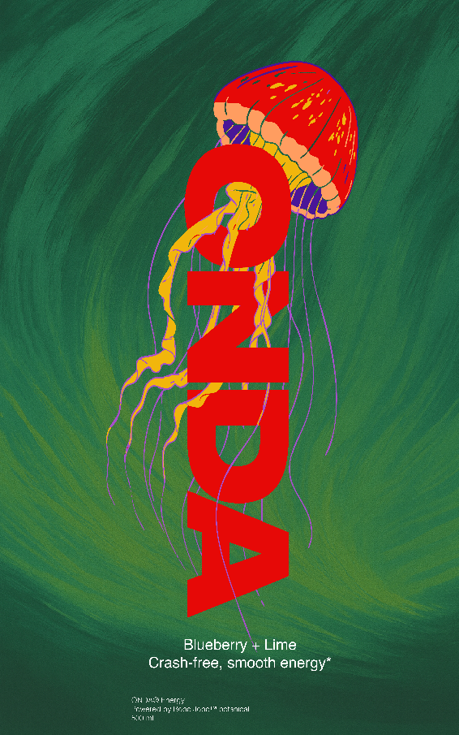
Figure 2: “Onda” can elements
MG also observed improvements over time, recalling that some jellyfish designs he was exploring eventually resembled a “famous motif,” and he appreciated moments where colour palettes and backgrounds felt coherent, such as a “green pattern background” that integrated seamlessly with his chosen mascot (see Figure 2). AA likewise expressed satisfaction when hybridising two GenAI outputs into a logo she liked, describing her final can as “funky” and “quite cool” (see Figure 3).
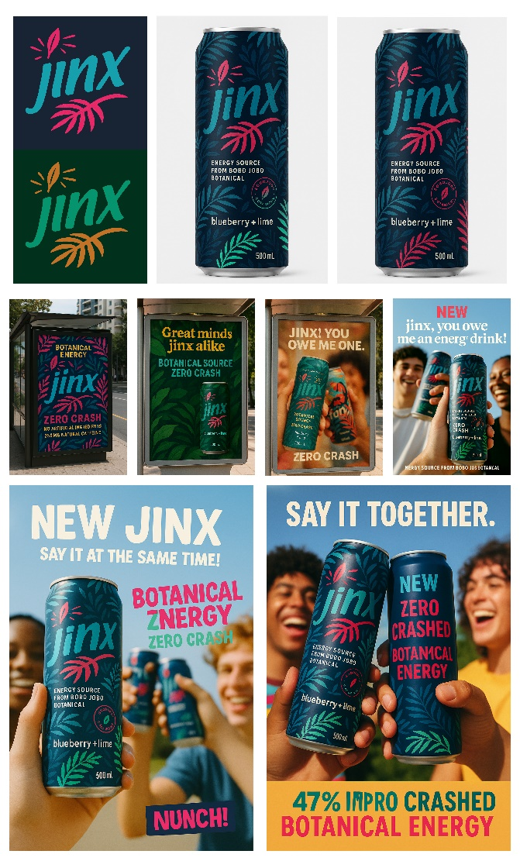
Figure 3: The Jinx energy drink and advertising mock-ups

For DF, the appeal lay in how the GenAI could apply simple foliage or logos consistently to can mock-ups, making the design process feel fluid and accessible (see Figure 4).
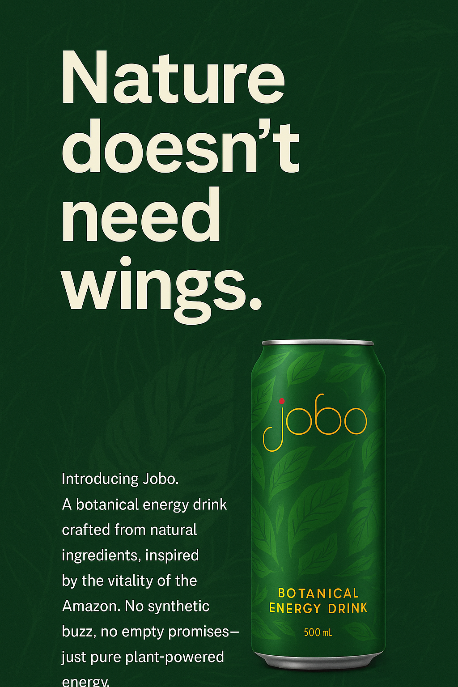
Figure 4: The textured “Jobo” energy drink can
Yet alongside these moments of satisfaction were recurring frustrations. Many of us described the outputs as inconsistent, with the GenAI prone to “losing fidelity” when refining logos, text, or small details. JM struggled with warning labels and wordmarks, where designs would “fall apart.” DF found the GenAI’s typography “rubbish” and overly basic, lamenting the “fat logos” it seemed to prefer despite his desire for thin minimalism. In the end, he hand-designed the typography for his can because it could never get it right (see Figure 5).
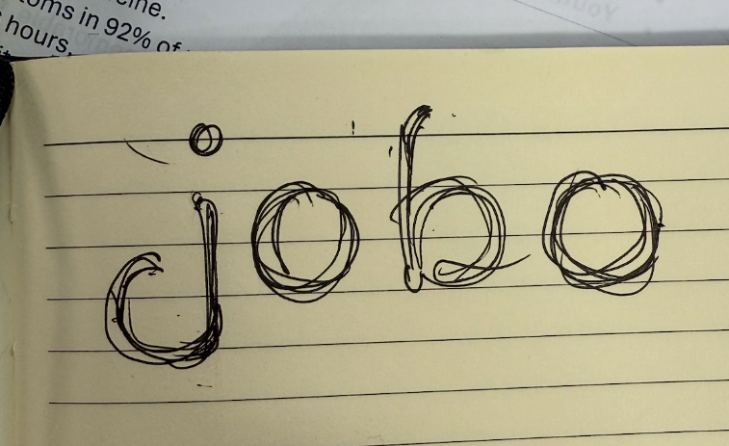
Figure 5: DF’s hand-drawn logo design that worked as inspiration
AA critiqued the fonts as “quite boring” and “safe options that don’t stand out,” while MG described the colour palettes as “terrible” and the attempts at clean line work for mascots as “garbage.” AD, who had clear preferences for earthy tones and organic patterns, became frustrated when the GenAI ignored specified instructions, such as completely changing a chosen red or when the can changed style when integrated into advertising assets (see Figures 6 & 7). In Figure 7, it was also clear that the GenAI struggled to develop the basketballer’s hand: a common issue with images constructed by GenAI models, which produce people typical of the uncanny valley (Keyes and Hyland). In short, across these experiences, the sense of creative misalignment was clear.
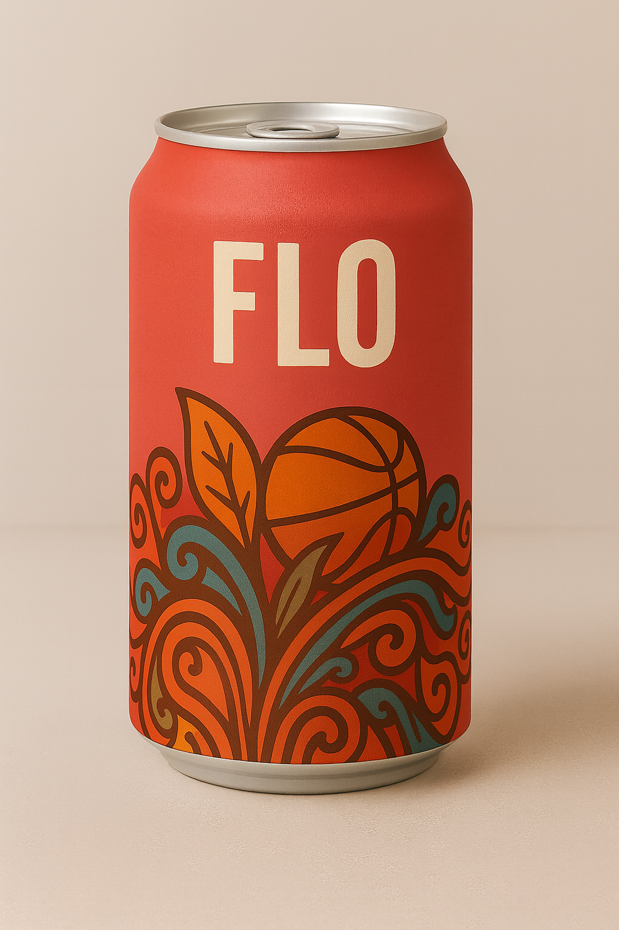
Figure 6: The final can Figure 7: The can losing its design elements
These frustrations align with what scholars have noted about the limits of AI-driven creativity. Rather than producing genuinely novel ideas, generative systems tend to recycle established design conventions embedded in their training data, which gives the work a generic or predictable quality. For us, this meant that while the outputs could appear visually striking at first glance, they often revealed an underlying artifice. What looked like creativity was in fact the GenAI reverting to familiar stylistic tropes, leading to results that felt shallow or mismatched with the more nuanced experimentation and originality we were aiming for (Matthews et al.; Runco).
A unifying critique was the perception that the GenAI’s aesthetics leaned toward the generic, evoking a “templated” quality. AD was blunt, saying that “everything looks like it was made in Canva… this is still just another Canva image at the end,” estimating that outputs fell into “90% of the barrel” of common design work rather than the “phenomenal 10%” of originality. AA saw echoes of big brands, such as a logo that looked “way too similar to Nike,” while DF dismissed many GenAI name suggestions as “pretty vanilla” and described typography as basic stock replications. MG wanted to avoid “cliché energy drink” imagery, which he felt often appeared “a bit cheese,” and JM, while more accepting, still admitted that the GenAI “has got its biases, and its training data,” pointing out that much of design is already “versions of the same thing.”
These observations can be connected to the broader democratisation of the technology: because GenAI draws on vast pools of mainstream visual references, it inevitably reproduces the dominant aesthetics that circulate most widely (Ahmed and Ali; Chamakiotis and Panteli; Matthews et al). In this sense, the similarity of outputs is less a flaw in the system than an extension of how design itself functions intertextually, with all creative work borrowing from and echoing prior styles (Baron; Shahariar). To expect GenAI to transcend these paradigms may, therefore, be unrealistic, given that its models are grounded in training data that mimic design and stylistic biases (Atkinson and Barker). What we encountered, then, was not so much a failure of the technology as the exposure of its limitations in pushing beyond conventions that are already deeply embedded in the cultural capital from which it learns.

Conclusion
Our findings suggest that working with GenAI is not a binary contest between human and machine, but an ongoing negotiation of creative control, aesthetic agency, and cultural value. Across our reflections, three mechanisms of co-creativity emerged: acceleration (AI as a catalyst for ideation and iteration), convergence (AI’s tendency to reproduce dominant aesthetic tropes), and refinement (the human expert’s capacity to critique and reframe AI outputs). Together, these reveal how expertise functions as both a filter and a counterweight, maintaining creative depth while navigating the efficiencies and biases of algorithmic generation.
Theoretically, this study extends debates in creative cognition and computational creativity by demonstrating that expert practitioners do not simply adapt to AI but actively curate its affordances within cultural and disciplinary norms. Practically, it shows that GenAI reshapes how creative labour is distributed and valued, demanding new literacies of critique, iteration, and authorship. Culturally, it illuminates how creative work with AI becomes a site where notions of originality, authenticity, and artistic authority are being renegotiated.
In this sense, GenAI does not merely assist creativity, it transforms the ecosystem in which creativity occurs. Understanding that transformation requires attention not only to the tools themselves but to the evolving practices, judgments, and aesthetic negotiations through which human expertise continues to matter.
References
Ahmed, Abdinor Abukar, and Mohamed Khalif Ali. “User-Centric Adoption of Democratized Generative AI: Focus on Human-Machine Interaction and Overcoming Challenges.” International Journal of Engineering Trends and Technology 72.9 (Sept. 2024): 78–95. ‹https://doi.org/10.14445/22315381/IJETT-V72I9P107›
Amankwah-Amoah, Joseph, Samar Abdalla, Emmanuel Mogaji, Amany Elbanna, and Yogesh K. Dwivedi. “The Impending Disruption of Creative Industries by Generative AI: Opportunities, Challenges, and Research Agenda.” International Journal of Information Management 79.1 (2024): 102759.
Atkinson, Paul, and Richie Barker. “AI and the Social Construction of Creativity.” Convergence: The International Journal of Research into New Media Technologies 29.4 (2023): 1054–69. ‹https://doi.org/10.1177/13548565231187730›
Baron, Scarlett. The Birth of Intertextuality: The Riddle of Creativity. New York: Routledge, 2019.
Bourdieu, Pierre. Distinction: A Social Critique of the Judgement of Taste. Trans. Richard Nice. Cambridge, MA: Harvard UP, 1984.
Braun, Virginia, and Victoria Clarke. Successful Qualitative Research: A Practical Guide for Beginners. Thousand Oaks: Sage, 2013
Chamakiotis, Petros, and Niki Panteli. “Unpacking the Relationship between Creativity and GenAI: The Role of Knowledge and Expertise.” ACIS 2024 Proceedings 16 (2024). ‹https://aisel.aisnet.org/acis2024/16›
Chang, Heewon. “Individual and Collaborative Autoethnography for Social Science Research.” Handbook of Autoethnography. Ed. Tony E. Adams, Stacy Holman Jones, and Carolyn Ellis. New York: Routledge, 2021. 139–65.
Coffin, Jack. “Asking Questions of AI Advertising: A Maieutic Approach.” Journal of Advertising 51.5 (2022): 608–23.
Csikszentmihalyi, Mihaly. “The Systems Model of Creativity and Its Applications.” The Wiley Handbook of Genius. Ed. Dean Keith Simonton. Hoboken: John Wiley & Sons, 2014. 686–704.
Cui, Weila, Martin J. Liu, and Ruizhi Yuan. “Exploring the Integration of Generative AI in Advertising Agencies: A Co-Creative Process Model for Human–AI Collaboration.” Journal of Advertising Research 65.2 (2025): 167–89. ‹https://doi.org/10.1080/00218499.2024.2445362›
DiStefano, Paul V., Daniel C. Zeitlen, Janet Rafner, Pier-Luc de Chantal, Aoran Peng, Scarlett Miller, and Roger E. Beaty. “Evaluating AI’s Ideas: The Role of Individual Creativity and Expertise in Human-AI Co-Creativity.” ResearchGate, ‹http://dx.doi.org/10.31234/osf.io/k2u87_v1›
Hartmann, Jochen, Yannick Exner, and Samuel Domdey. “The Power of Generative Marketing: Can Generative AI Create Superhuman Visual Marketing Content?” International Journal of Research in Marketing 42 (2025): 13–31.
Hettrich, Benjamin, Niklas Krings, and Alexander Kock. “Bridging the Expertise Gap: The Role of Generative AI in Supporting Project Planning Tasks for Novices and Professionals.” Creativity and Innovation Management 0 (2025): 1–17. ‹https://doi.org/10.1111/caim.70002›
Keyes, Oscar K., and Adam Hyland. “Hands Are Hard: Unlearning How We Talk About Machine Learning in the Arts.” Tradition Innovations in Arts, Design, and Media Higher Education 1.1 (2023): Article 4. ‹https://doi.org/10.9741/2996-4873.1004›
Lucchi, Nicola. "ChatGPT: a case study on copyright challenges for generative artificial intelligence systems." European Journal of Risk Regulation 15.3 (2024): 602-624.
Matthews, Justin, Daniel Fastnedge, and Angelique Nairn. “The Future of Advertising Campaigns: The Role of AI-Generated Images in Advertising Creative.” Journal of Pervasive Media 8.1 (2023): 29–49.
Nairn, Angelique, Justin Matthews, and Daniel Fastnedge. “Catering to clients: How artificial intelligence can influence the advertising agency-client dynamic.” Interactions: Studies in Communication & Culture 13.1 (2024): 133-146.
Osadchaya, Elena, Ben Marder, Jennifer A. Yule, Amy Yau, Laura Lavertu, Nikolaos Stylos, Sebastian Oliver, Rob Angell, Anouk de Regt, Liyu Gao, Kang Qi, Will Zhiyuan Zhang, Yiwei Zhang, Jiayuan Li, and Sara AlRabiah. “To ChatGPT, or Not to ChatGPT: Navigating the Paradoxes of Generative AI in the Advertising Industry.” Business Horizons 67 (2024): 571–81. ‹https://doi.org/10.1016/j.bushor.2024.05.002›
Runco, Mark A. “AI Can Only Produce Artificial Creativity.” Journal of Creativity 33 (2023): 100063. ‹https://doi.org/10.1016/j.yjoc.2023.100063›
Shahariar, Md. Golam. “Intertextuality in Arts and Literature: A Postmodern Phenomenon.” South Asian Research Journal of Arts, Language and Literature 5.6 (Nov.–Dec. 2023). ‹https://doi.org/10.36346/sarjall.2023.v05i06.001›
Smith, Naomi, and Clare Southerton. “AI and Aesthetic Alienation: The Image and Creativity in Contemporary Culture.” Social Science Computer Review 0.0 (2025): 1–10.
Torrance, Andrew W., and Bill Tomlinson. "Training is everything: Artificial intelligence, copyright, and" fair training"." Dickinson L. Rev. 128 (2023): 233-256.

